<https://www.youtube.com/watch?v=vMh0zPT0tLI&list=PLblh5JKOoLUICTaGLRoHQDuF_7q2GfuJF&index=48>



Today we're going to talk about stochastic gradient descent and it's gonna be clearly explained.

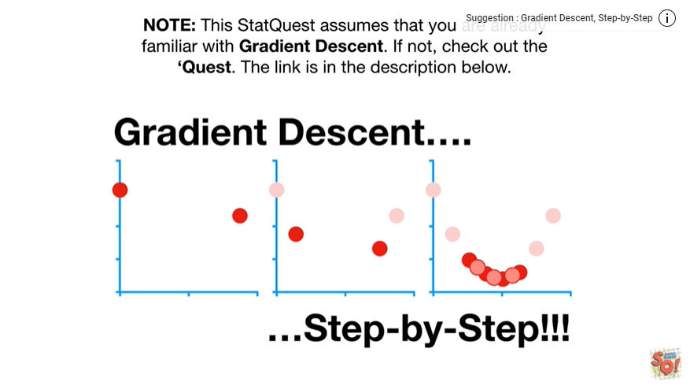

Note : this stat quest assumes that you are already familiar with gradient descent, if not, check out the quest.

The link is in the description below.

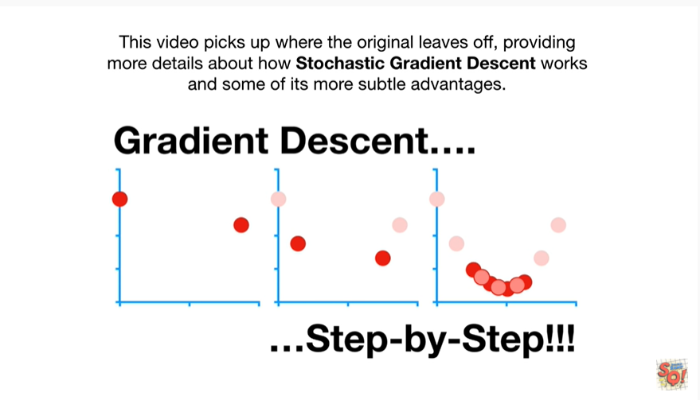

This video picks up where the original leaves off providing more details about how stochastic gradient descent works in some of its more subtle advantages.

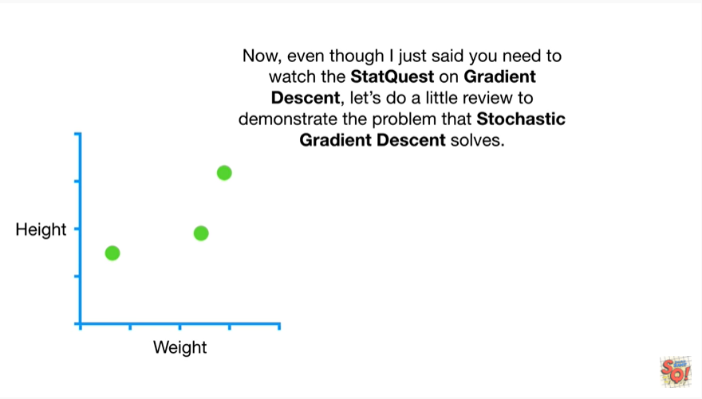

Now, even though I just said you need to watch the stat quest on gradient descent, let's do a little review to demonstrate the problem that stochastic gradient descent solves.

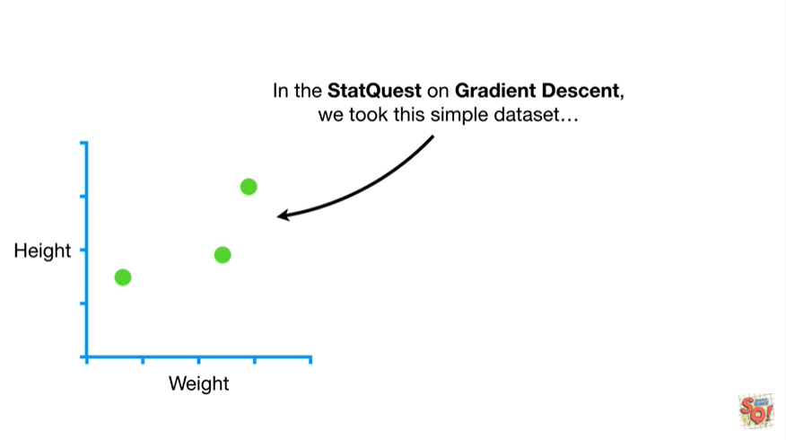

In the stat quest on gradient descent we took this simple data set

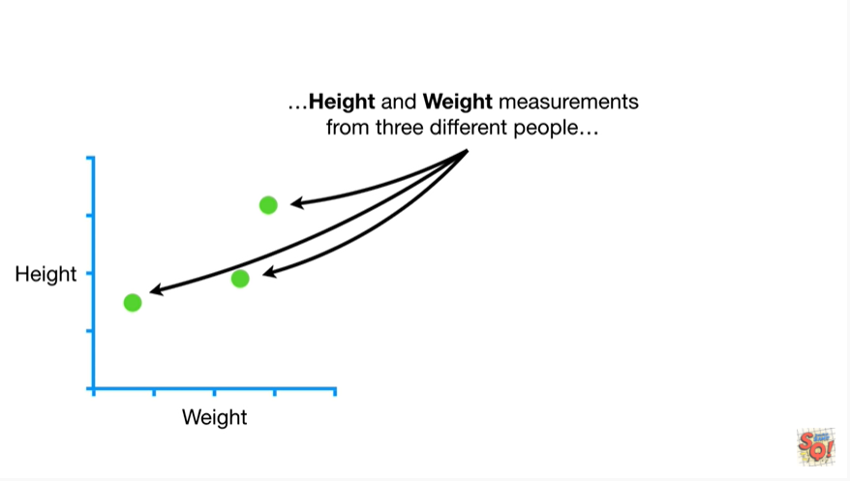

height and weight measurements from three different people

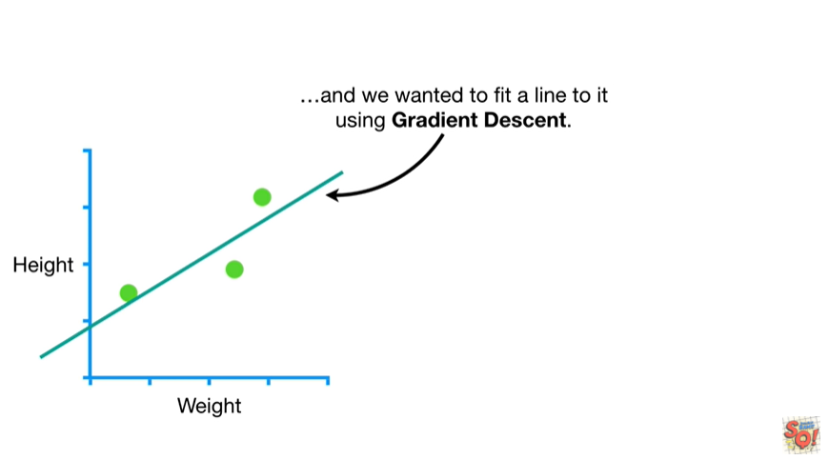

and we want it to fit a line to it using gradient descent.

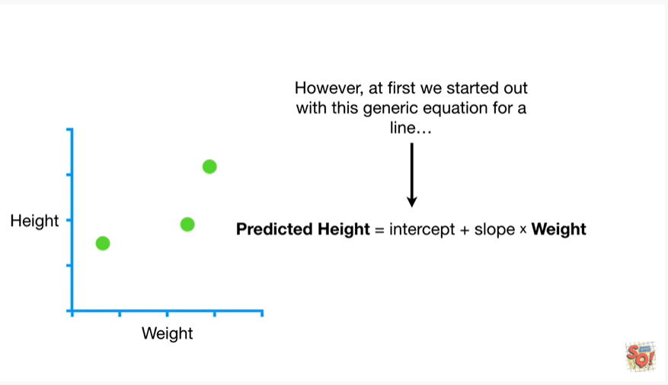

However, at first we started out with this generic equation for a line

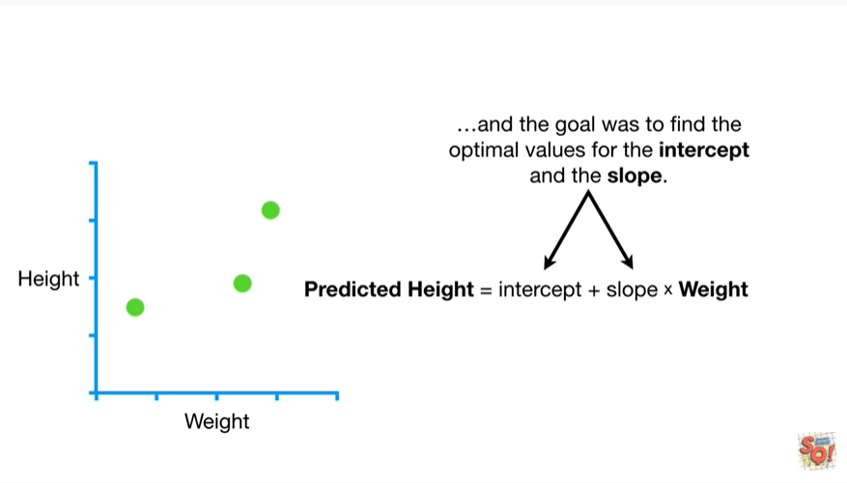

and the goal was to find the optimal values for the intercept and the slope.

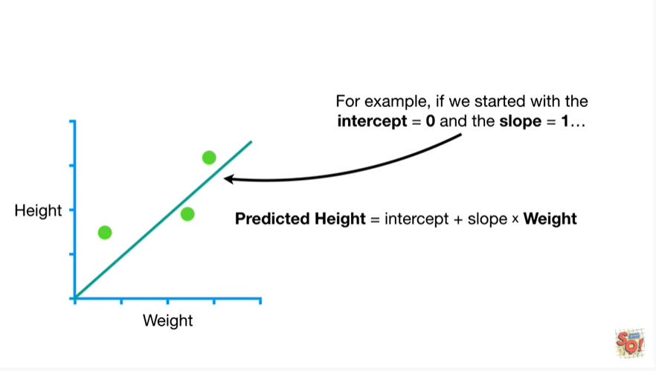

For example, if we started with the intercept equals 0 and the slope equals 1

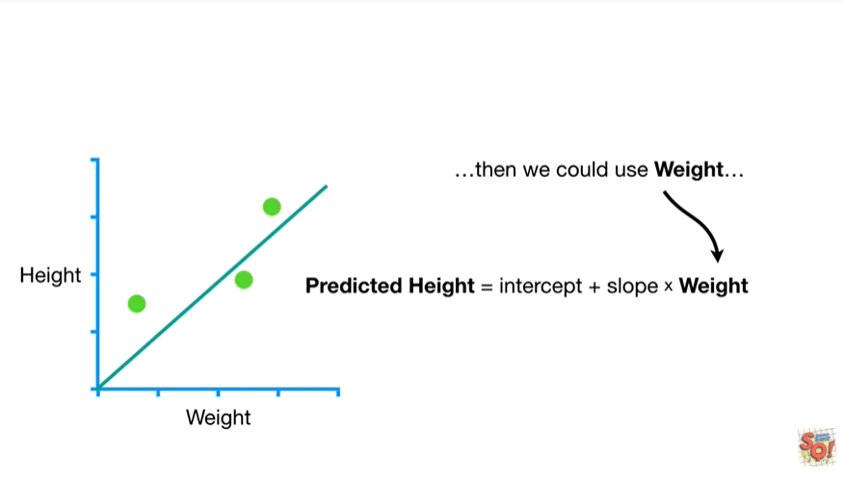

then we could use weight

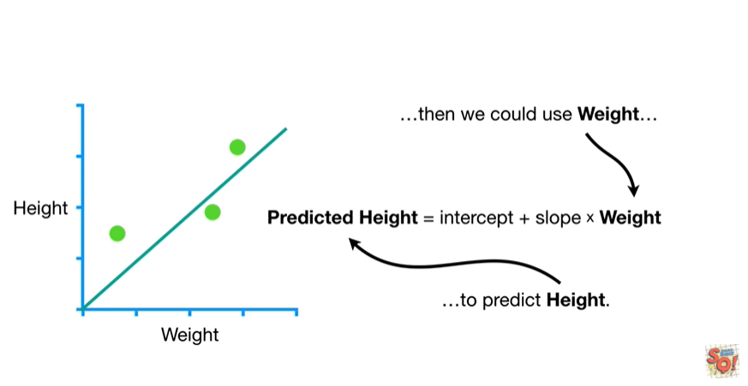

to predict height.

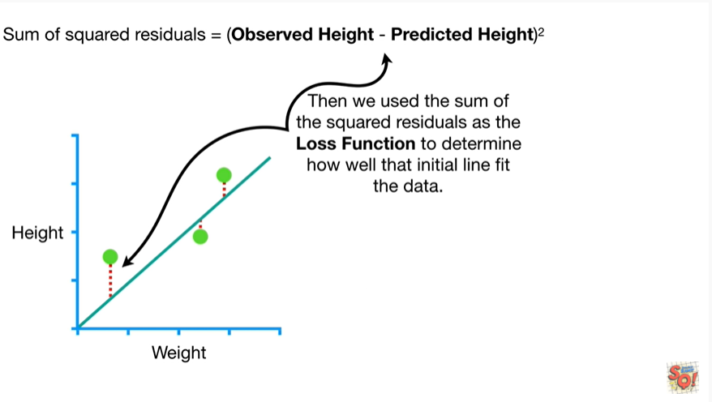

Then we would use the sum of the squared residuals as the loss function to determine how well the initial line fit the data.

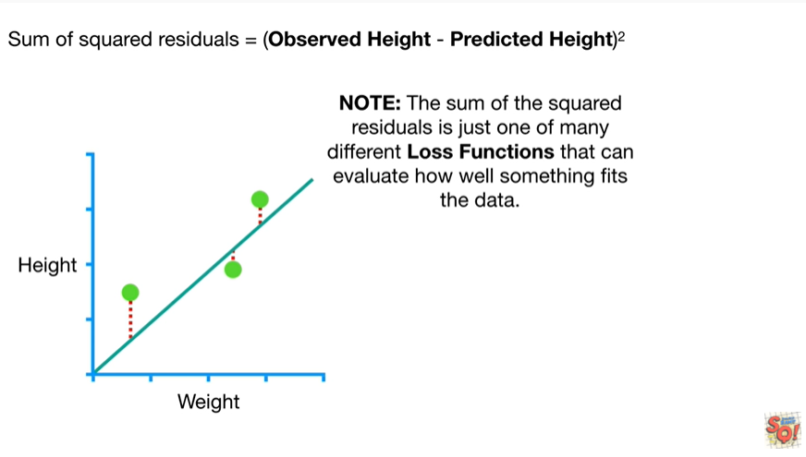

Note : the sum of the squared residuals is just one of many different loss functions that can evaluate how well something fits the data.

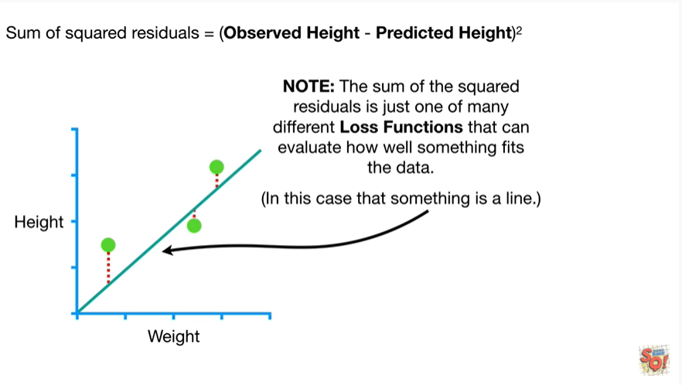

In this case that something is a line.

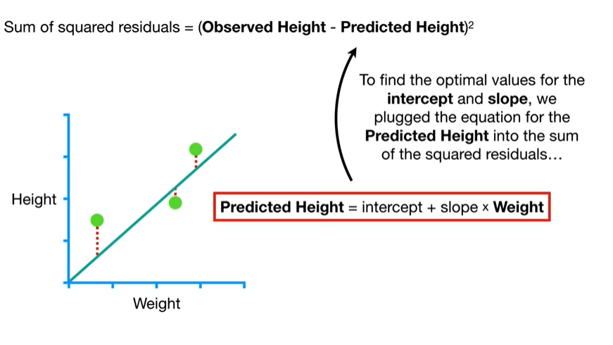

To find the optimal values for the intercept and slope we plug the equation for the predicted height into the sum of the squared residuals

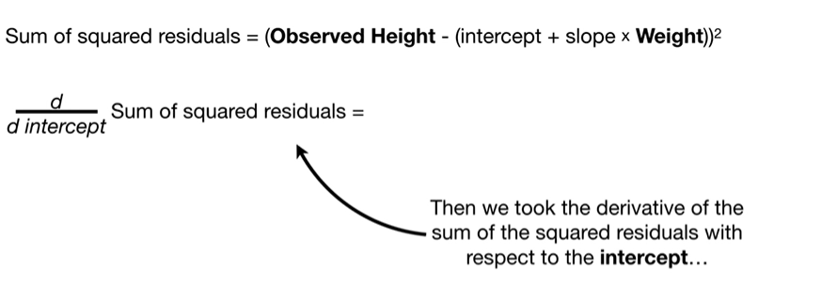

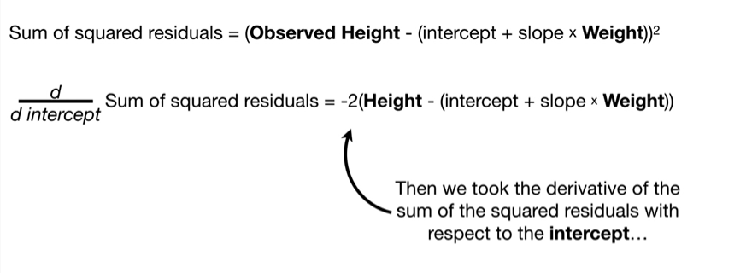

then we took the derivative of the sum of the squared residuals with respect to the intercept

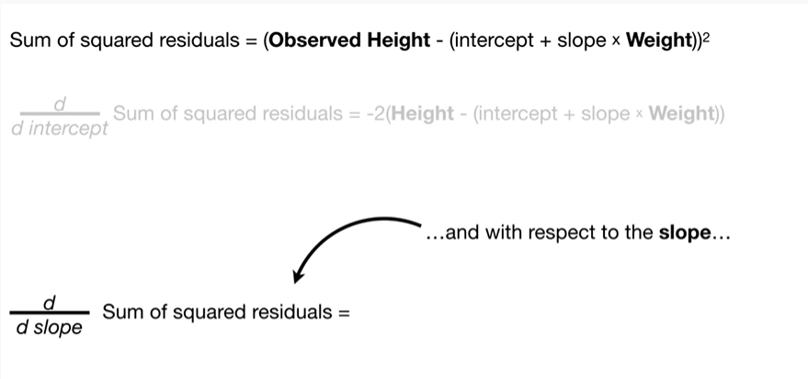

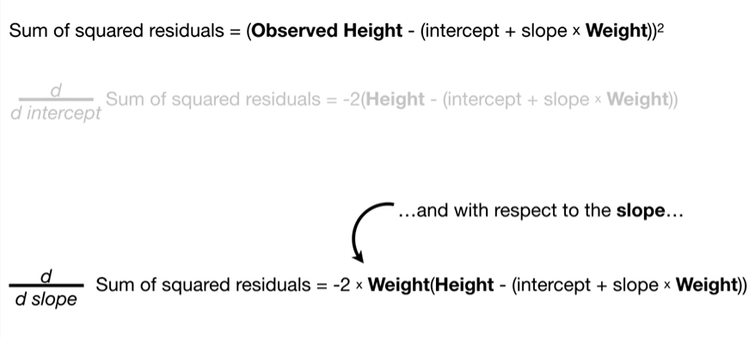

and with respect to the slope.

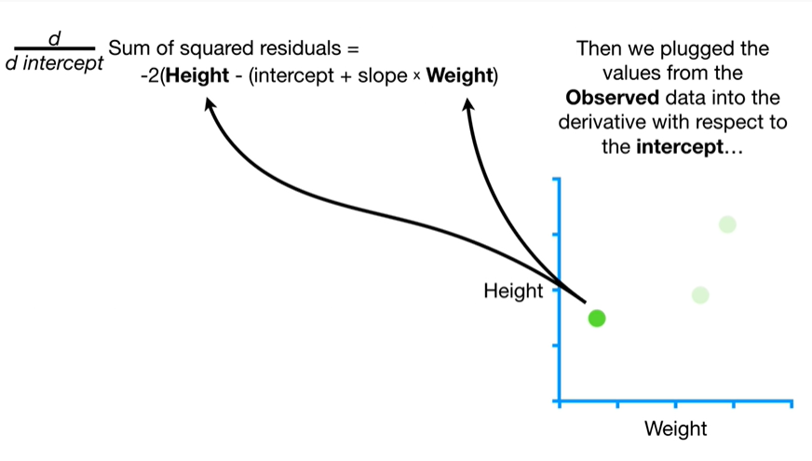

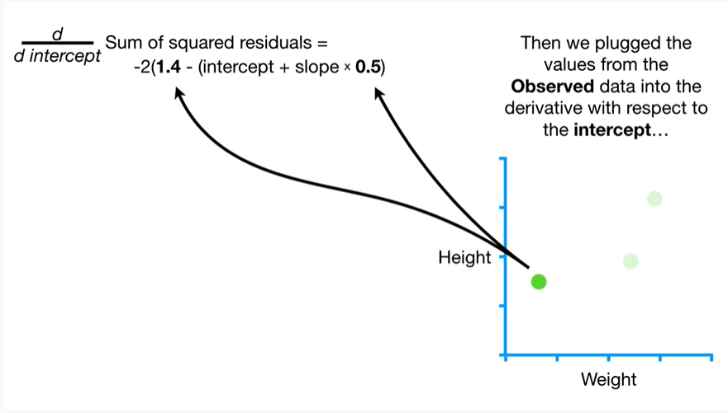

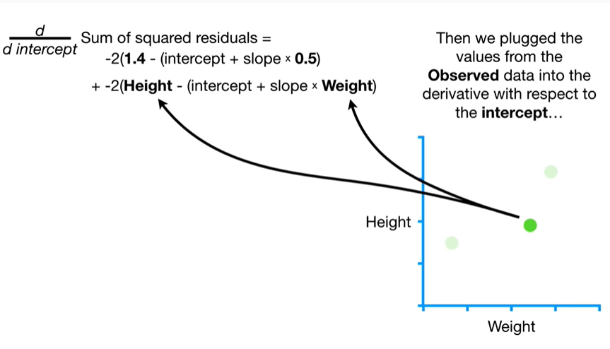

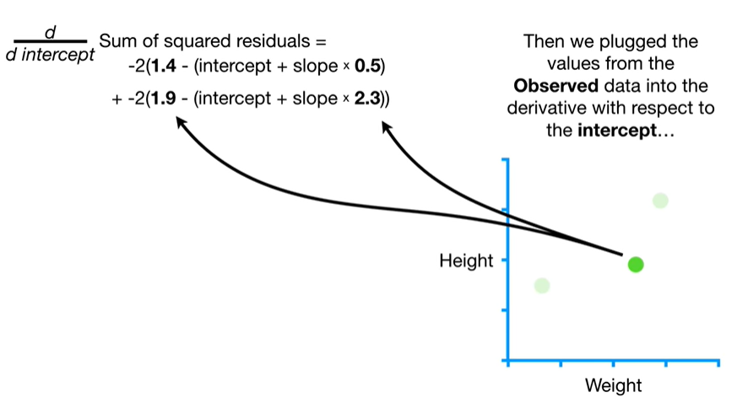

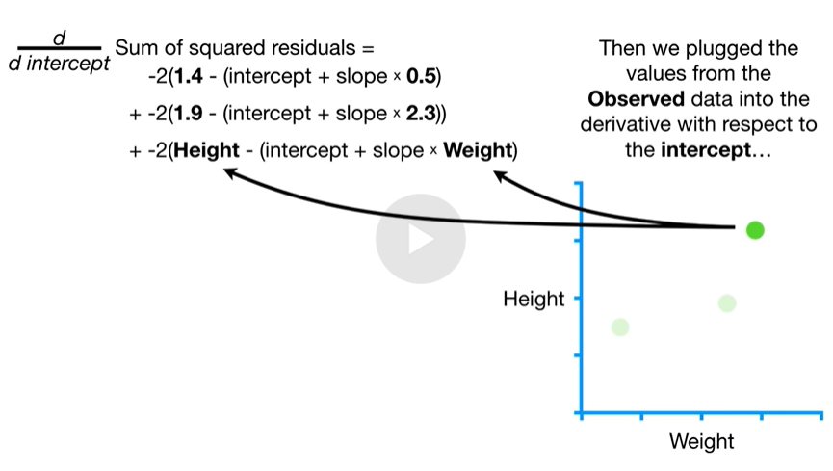

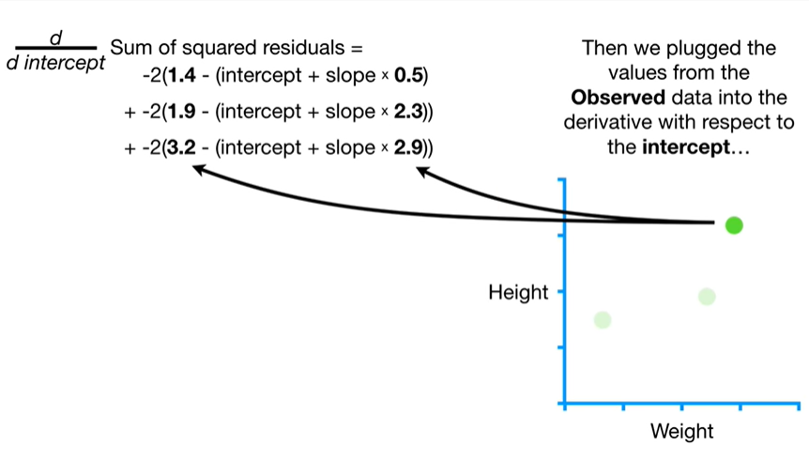

Then we plugged in the values from the observed data into the derivative with respect to the intercept

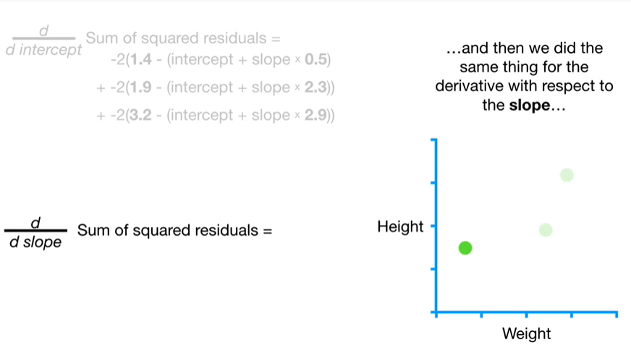

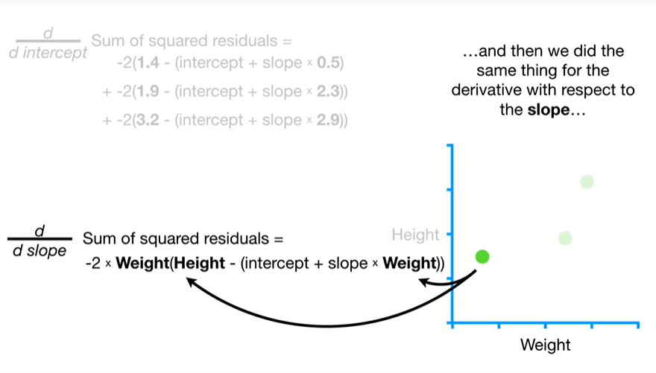

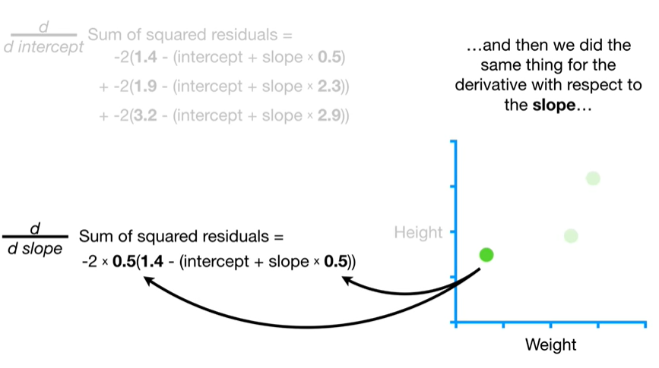

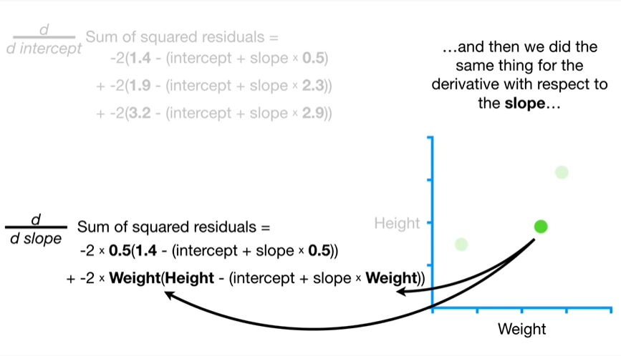

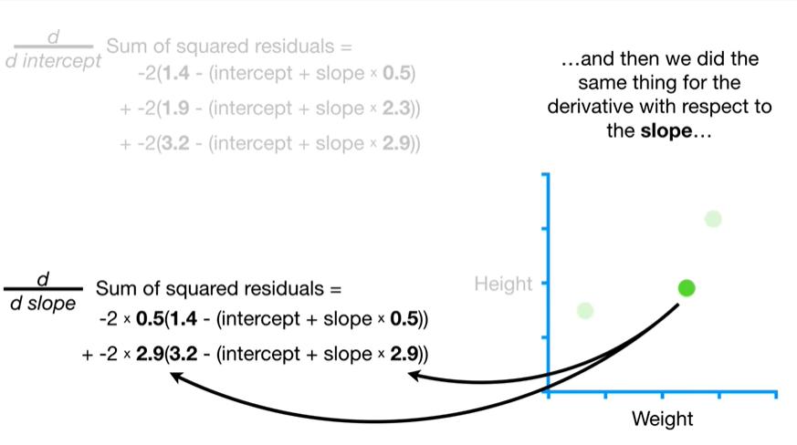

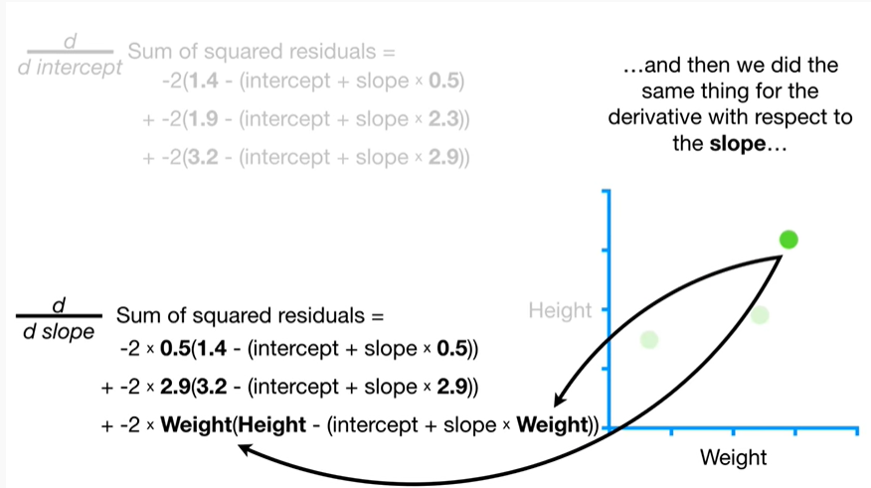

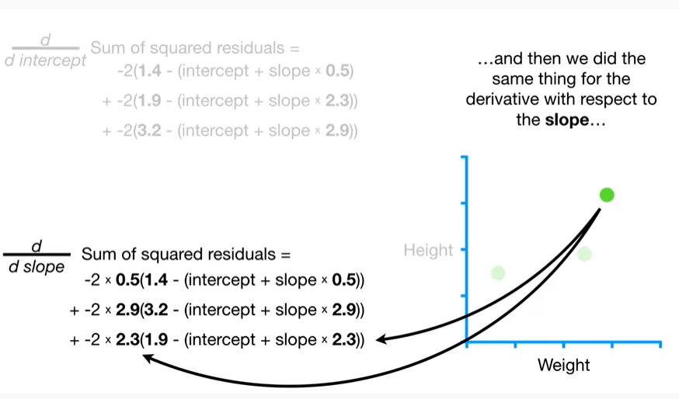

and then we did the same thing for the derivative with respect to the slope.

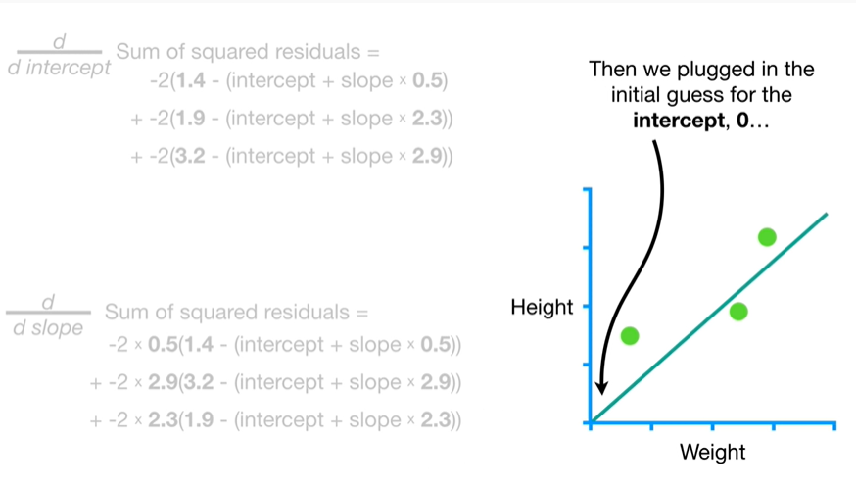

Then we plugged in the initial guess for the intercept,

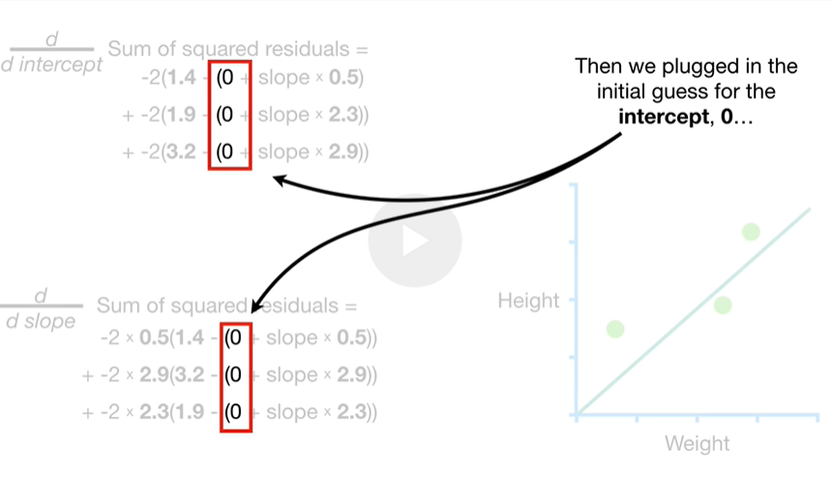

0

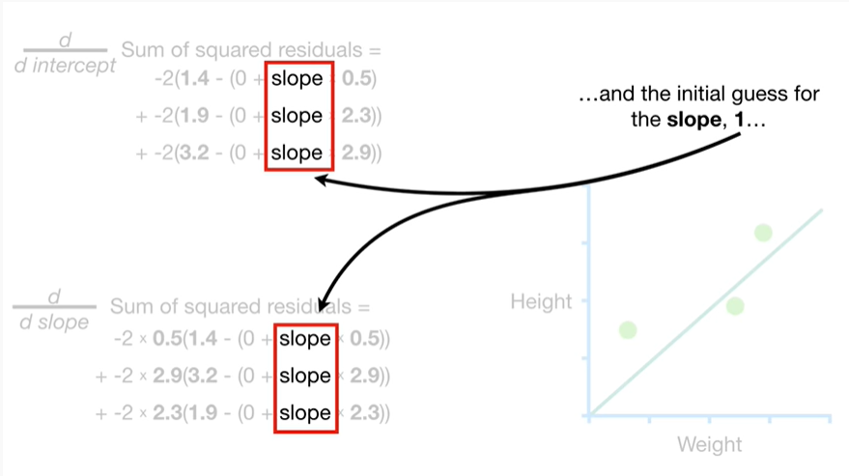

and the initial guess for the slope

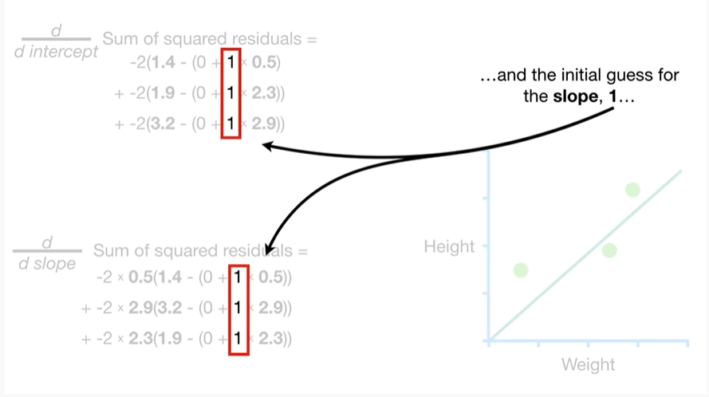

1

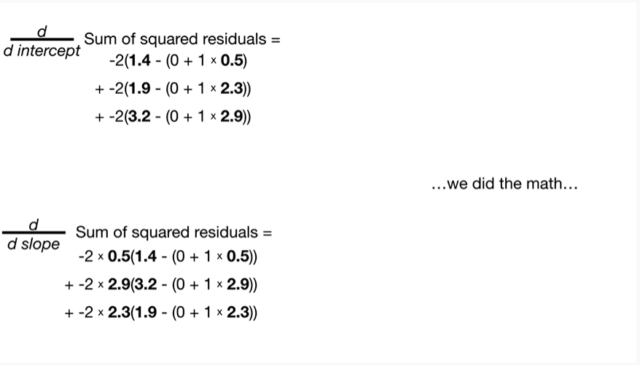

we did the math

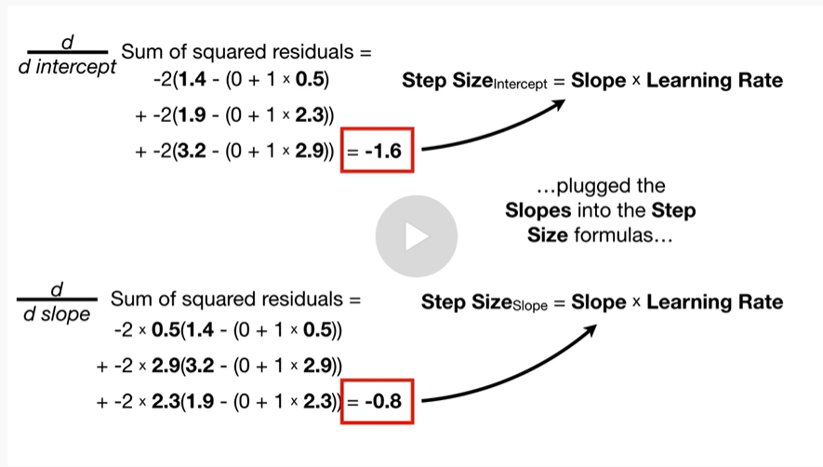

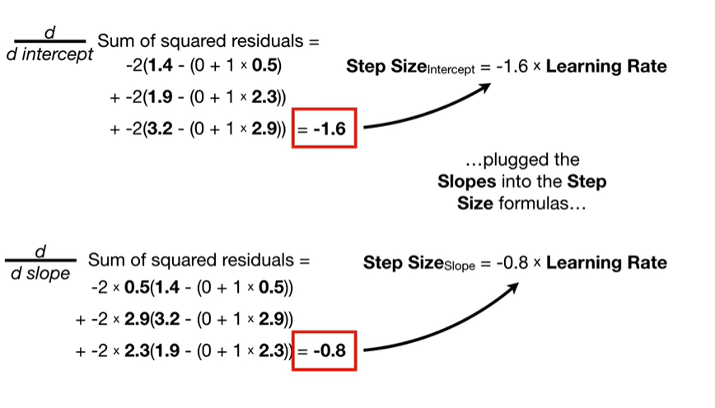

plug the slopes into the step size formulas

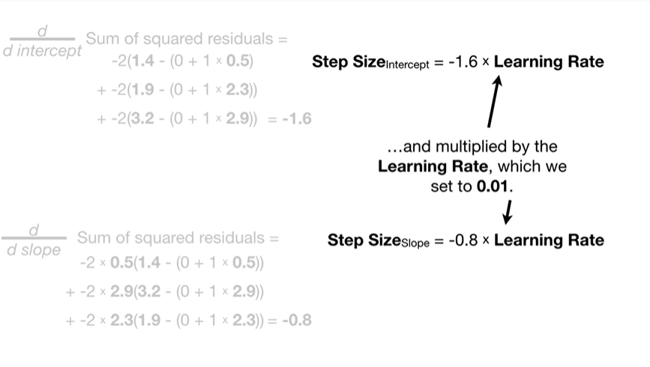

and multiplied by the learning rate which we set to 0.01.

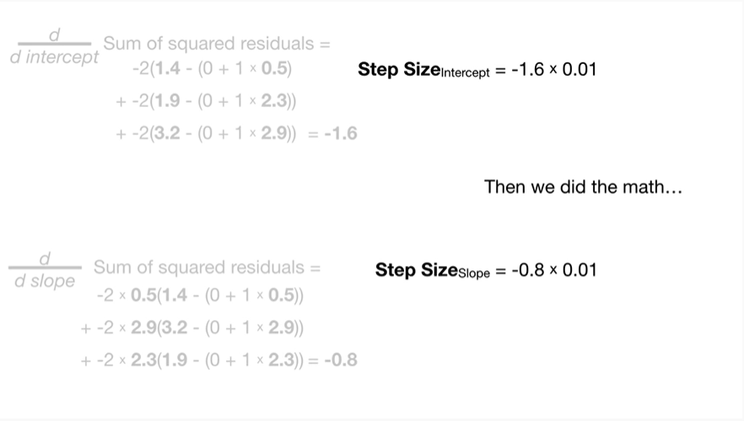

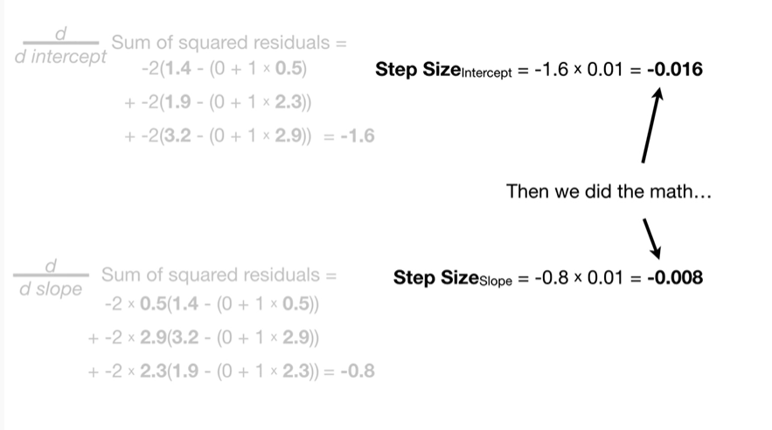

Then we did the math

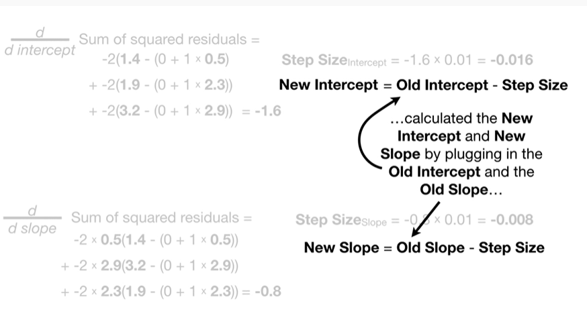

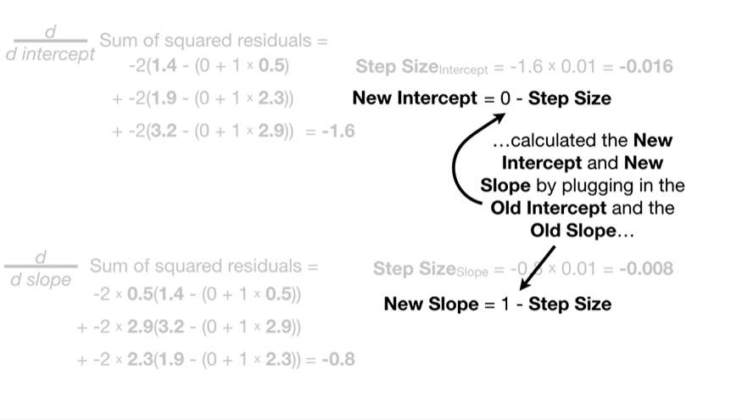

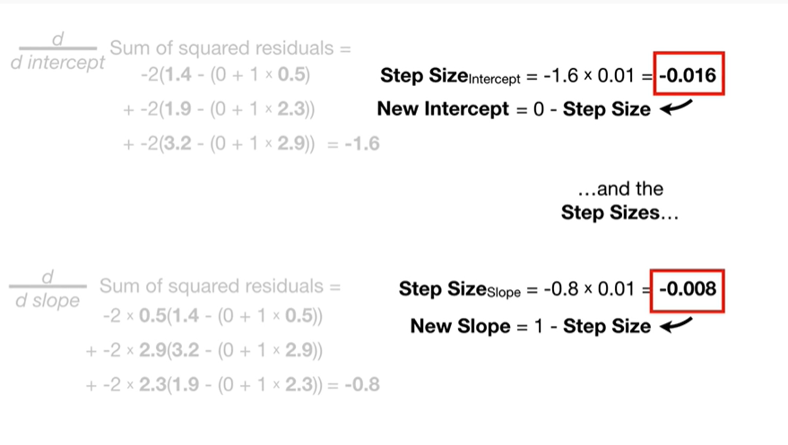

calculated the new intercept and new slope by plugging in the old intercept an old slope and the step sizes

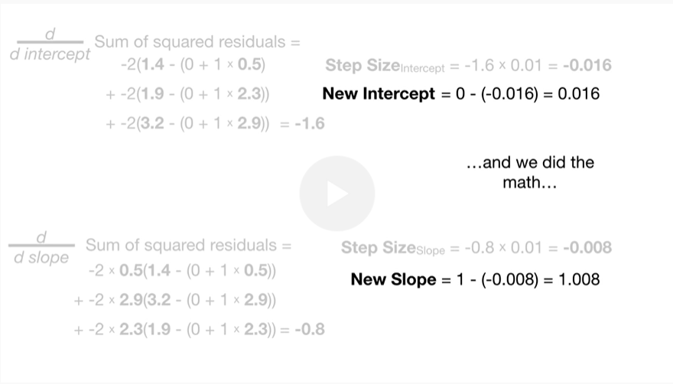

and we did the math

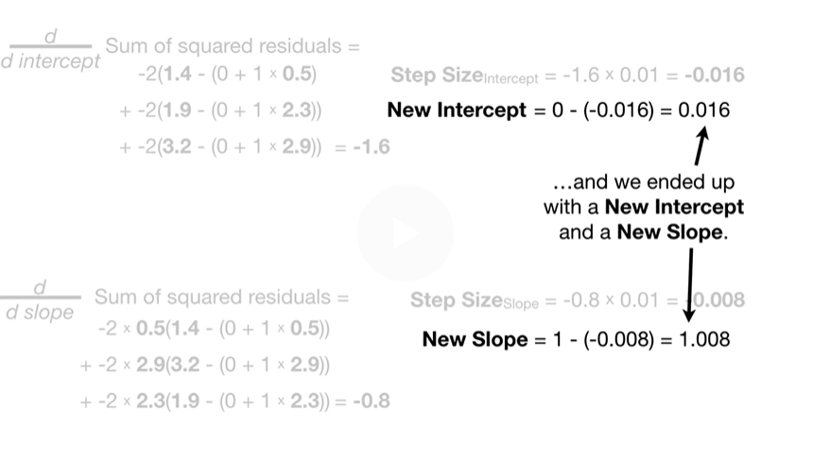

and we ended up with a new intercept and a new slope.

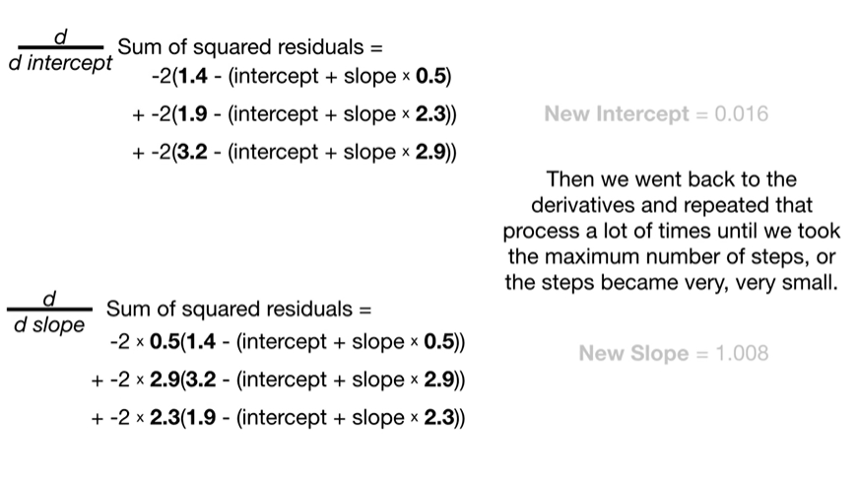

Then we went back to the derivatives and repeated the process a lot of times until we took the maximum number of steps, or the steps became very, very small.

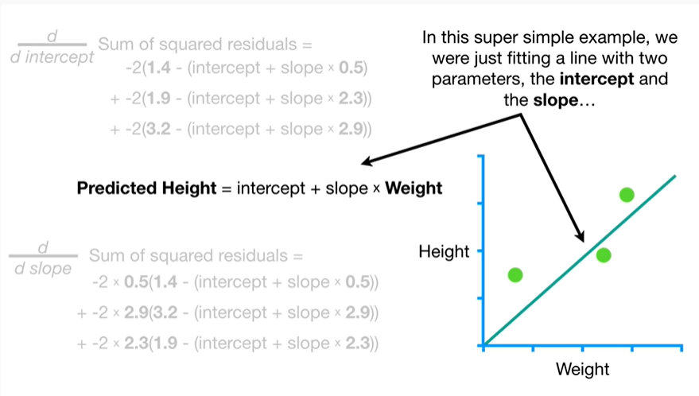

In this super simple example we were just fitting a line with two parameters the intercept and the slope

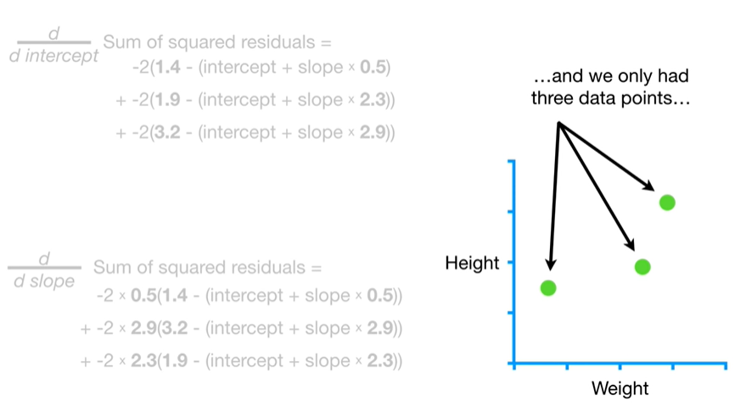

and we only had three data points

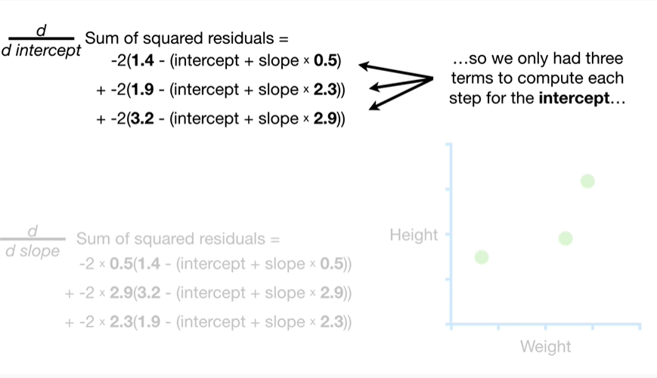

so we only had three terms to compute each step for the intercept

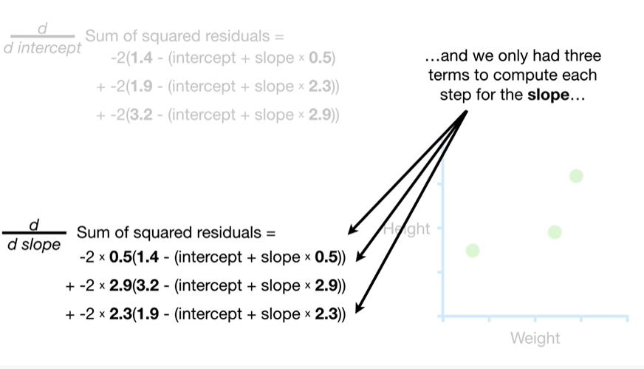

and we only had three terms to compute each step for the slope

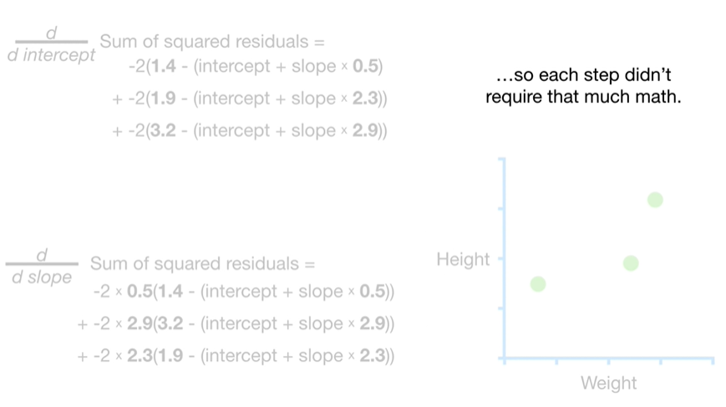

so each step didn't require much math.

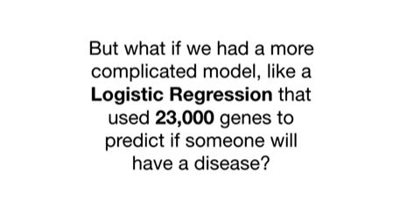

But what if we had a more complicated model like a logistic regression that used 23,000 genes to predict if someone will have a disease.

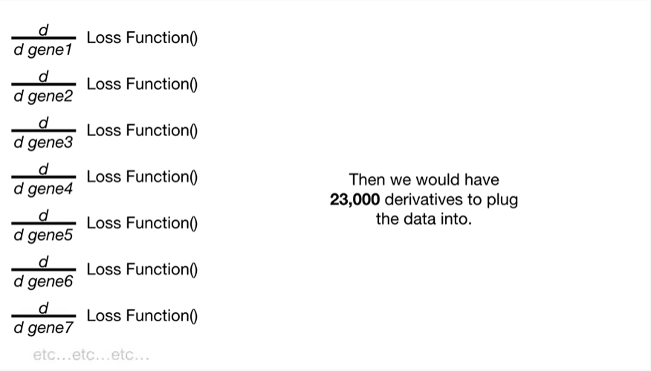

Then we will have 23,000 derivatives to plug the data into.

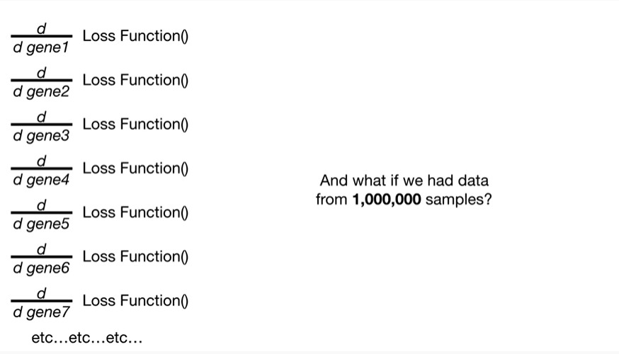

And what if we have data from 1 million samples ?

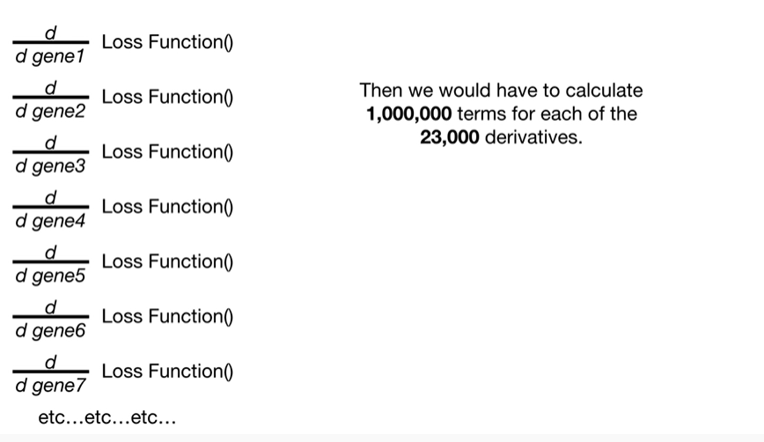

Then we would have to calculate 1 million terms for each of the 23,000 derivatives.

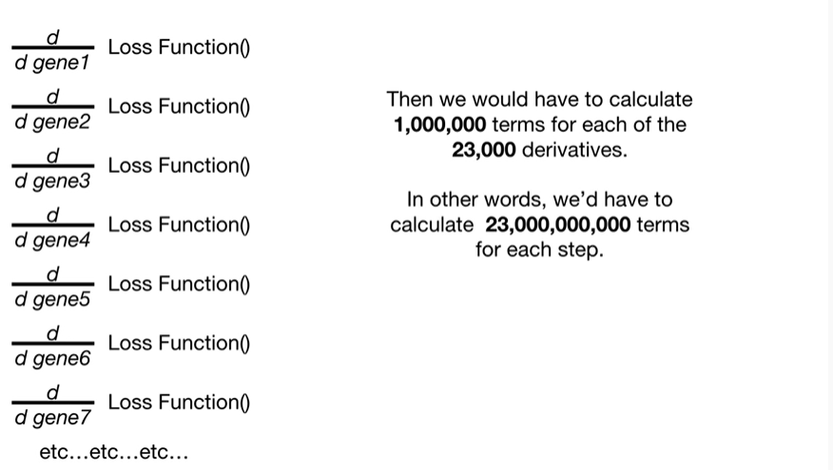

In other words we'd have to calculate 23 billion terms for each step.

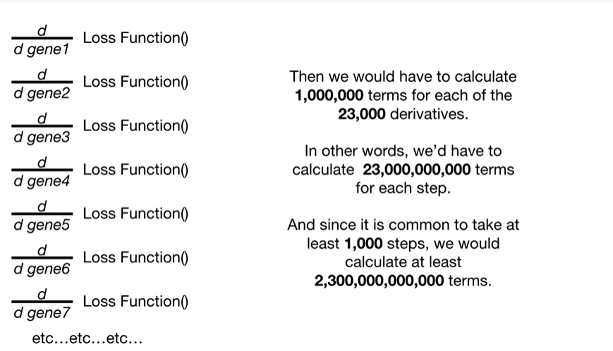

And since it's common to take at least 1,000 steps we would calculate at least two point three trillion terms.

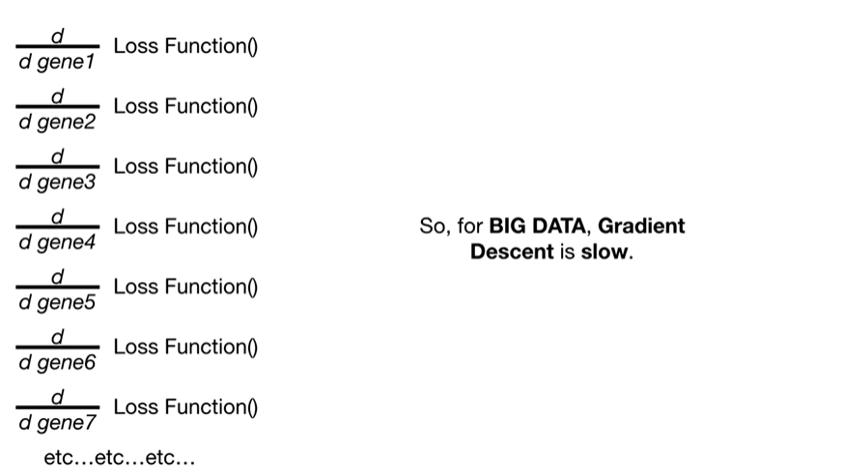

So, for big data, gradient descent is slow.

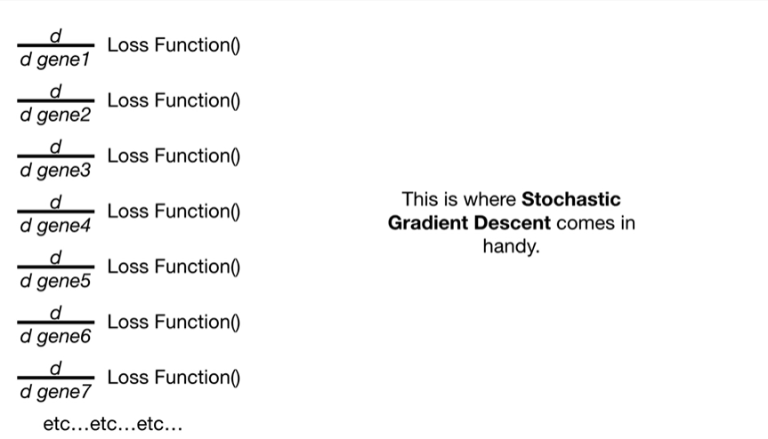

This is where stochastic gradient descent comes in handy.

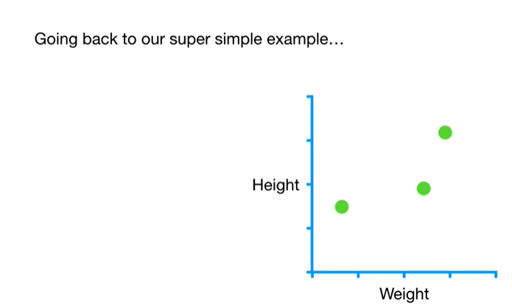

Going back to our super simple example

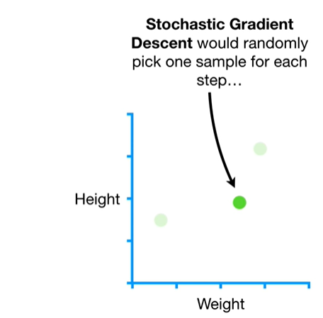

stochastic gradient descent would randomly pick one sample for each step

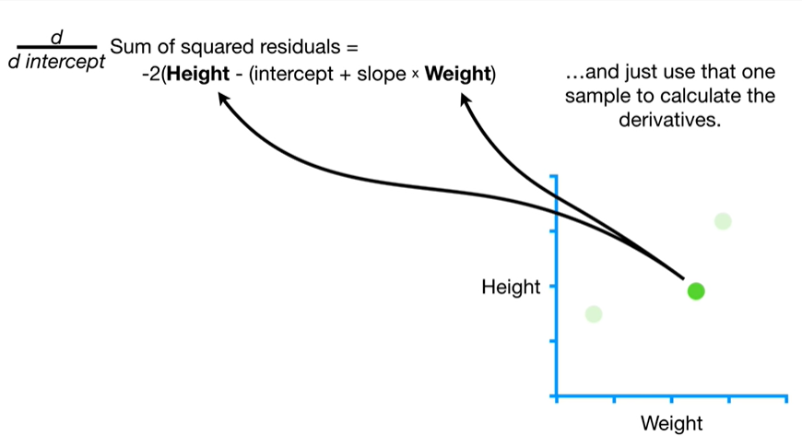

and just use that one sample to calculate the derivatives.

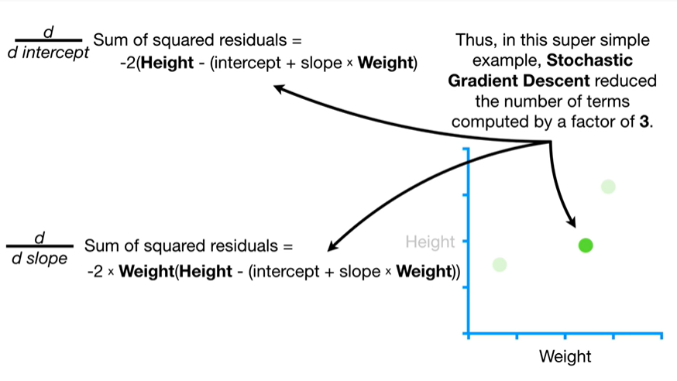

Thus, in this super simple example, stochastic gradient descent reduced the number of terms computed by a factor of three.

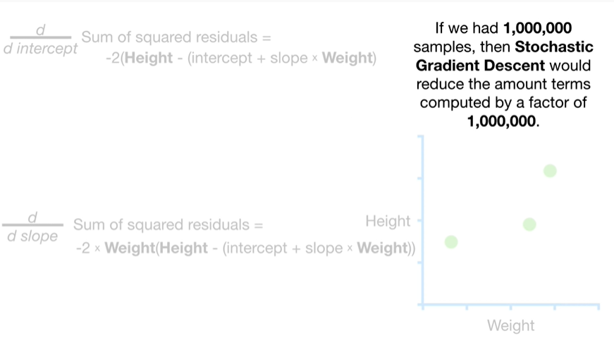

If we had 1 million samples then stochastic gradient descent would reduce the amount of terms computed by a factor of 1 million.

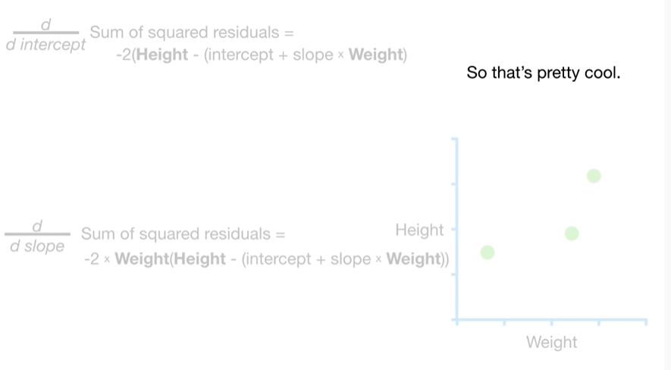

So that's pretty cool.

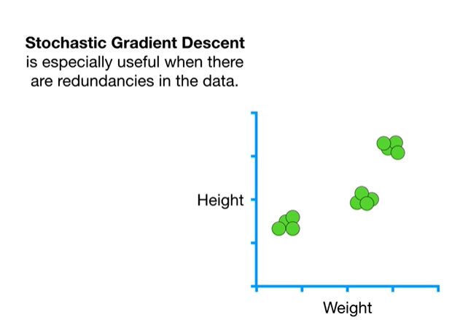

Stochastic gradient descent is especially useful when there are redundancies in the data.

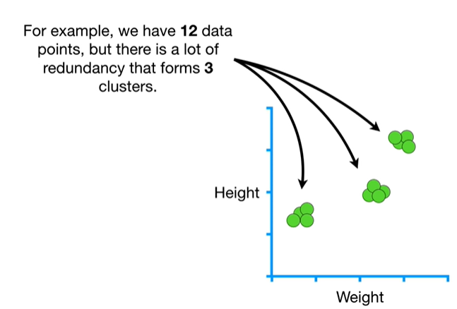

For example, we have 12 data points but there is a lot of redundancy that forms three clusters.

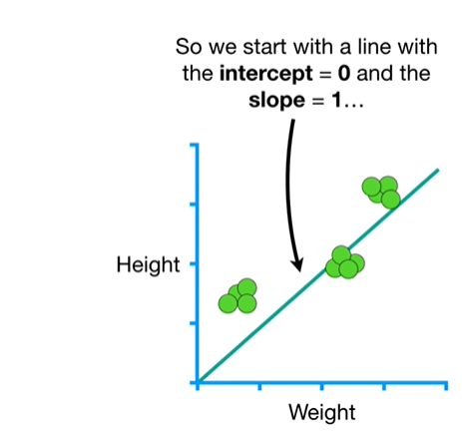

So we start with a line with the intercept equals 0 and the slope equals 1

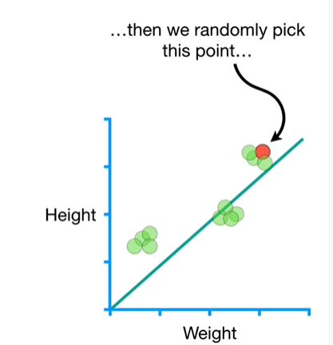

then we randomly pick this point

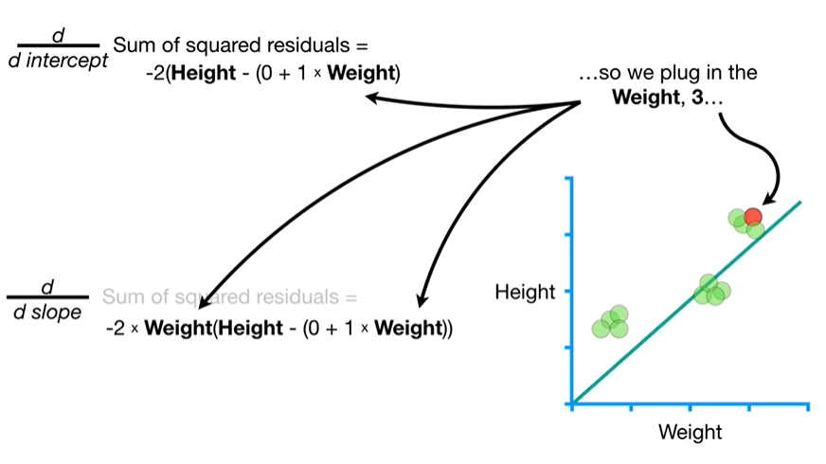

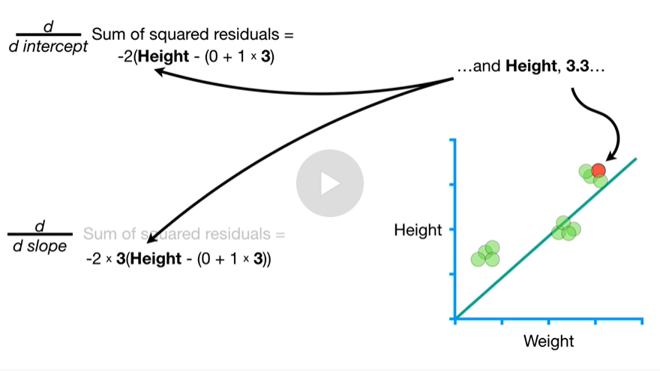

so we plug in the weight three

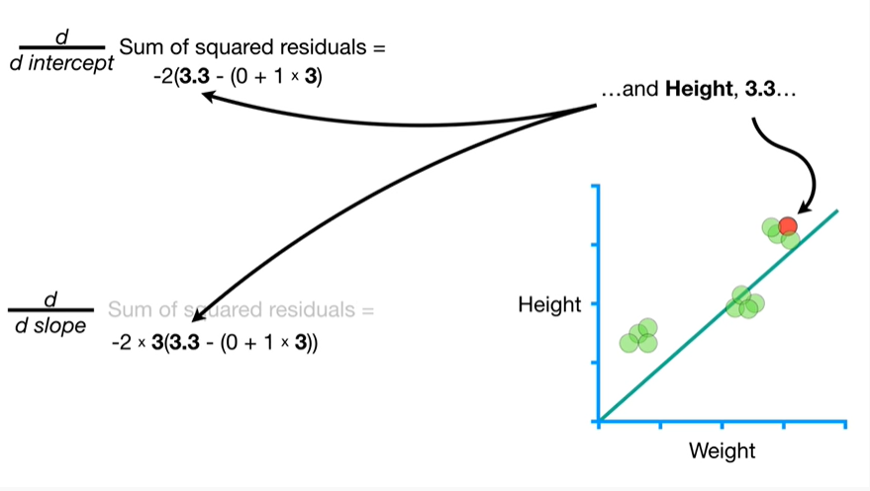

and height three point three

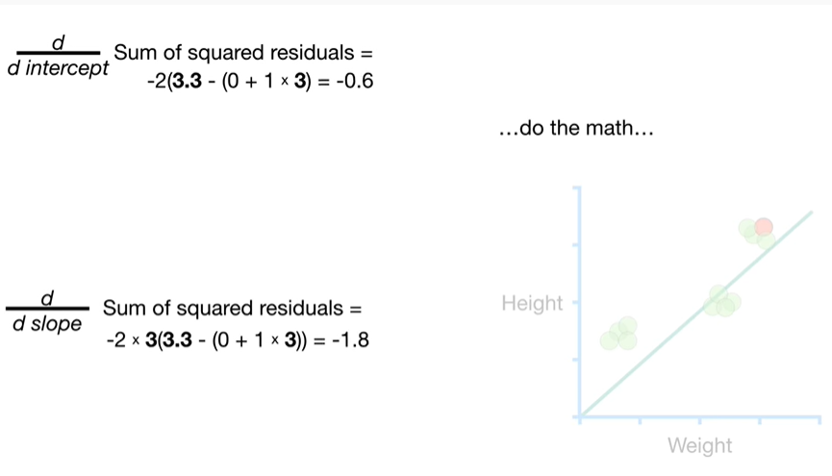

do the math

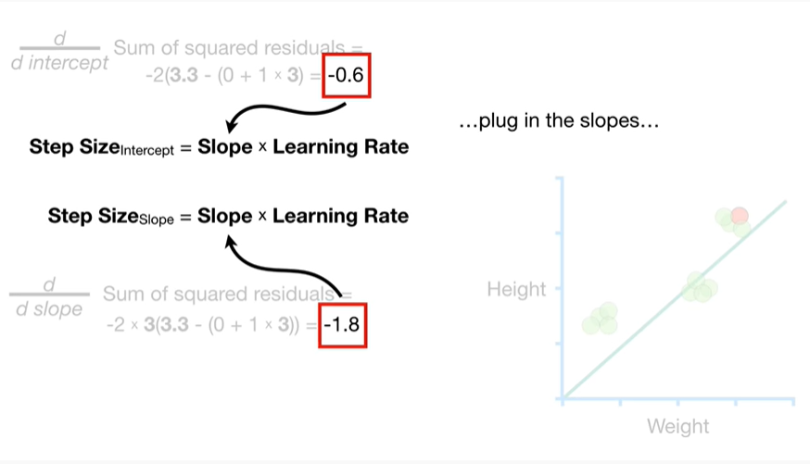

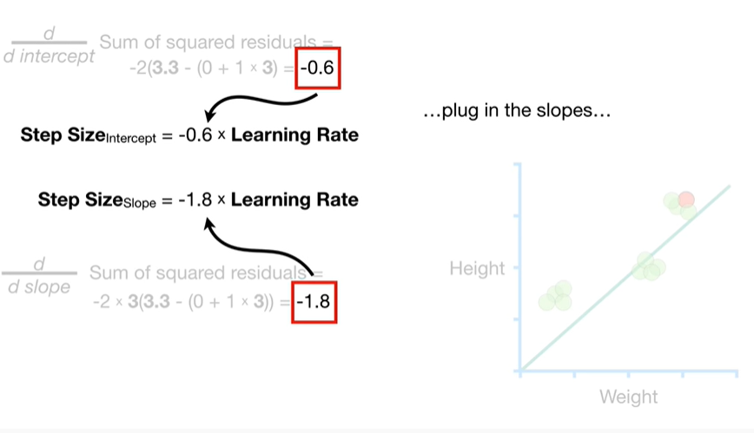

plug in the slopes

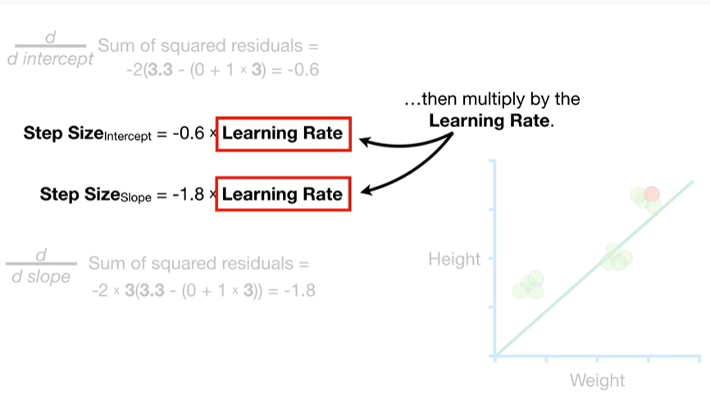

then multiply by the learning rate.

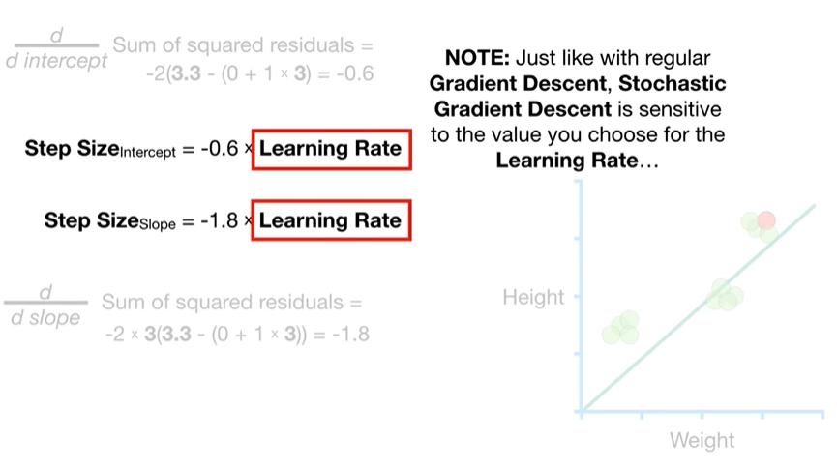

Note : just like with regular gradient descent stochastic gradient descent is sensitive to the value you choose for the learning rate

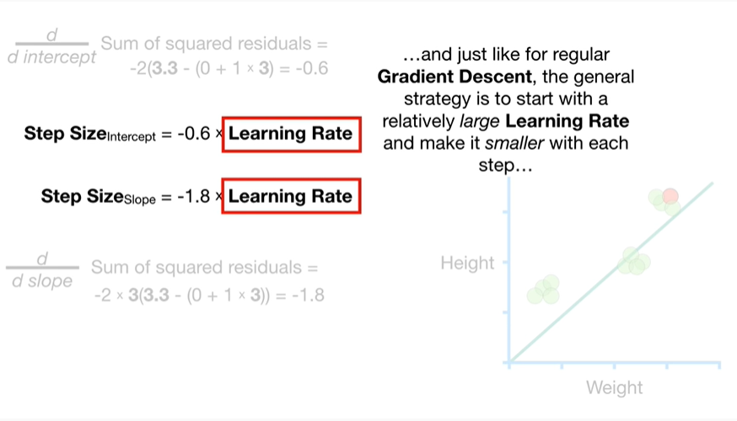

and just like for regular gradient descent the general strategy is to start with a relatively large learning rate and make it smaller with each step

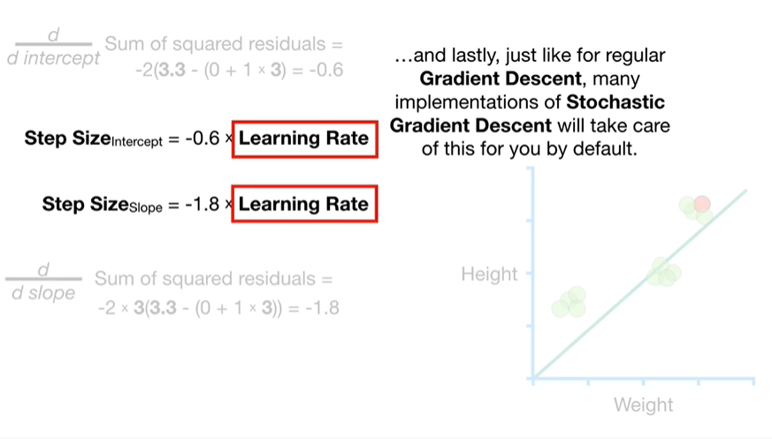

and lastly just like for regular gradient descent, many implementations of stochastic gradient descent will take care of this for you by default.

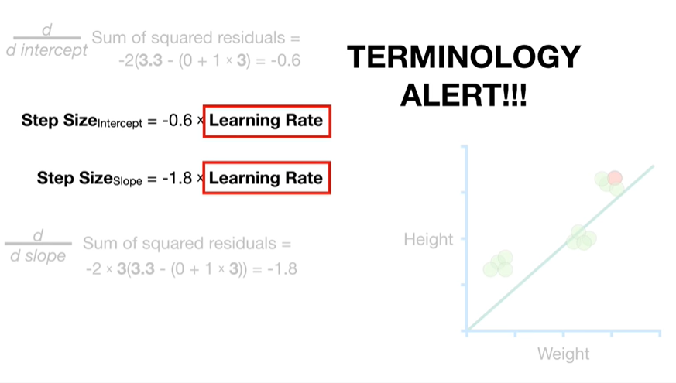

Oh no, it's a terminology alert !!!

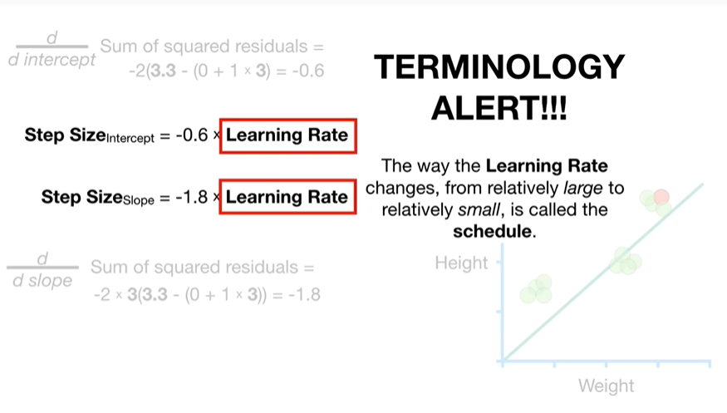

The way the learning rate changes from relatively large to relatively small, is called the schedule.

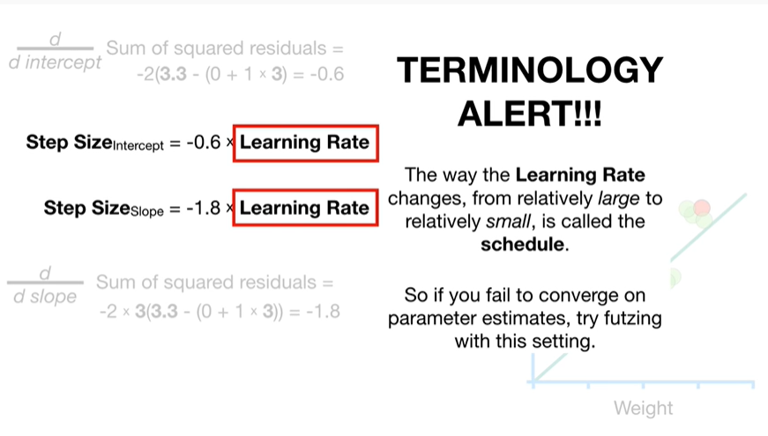

So if you fail to converge on parameter estimates try futzing with this setting.

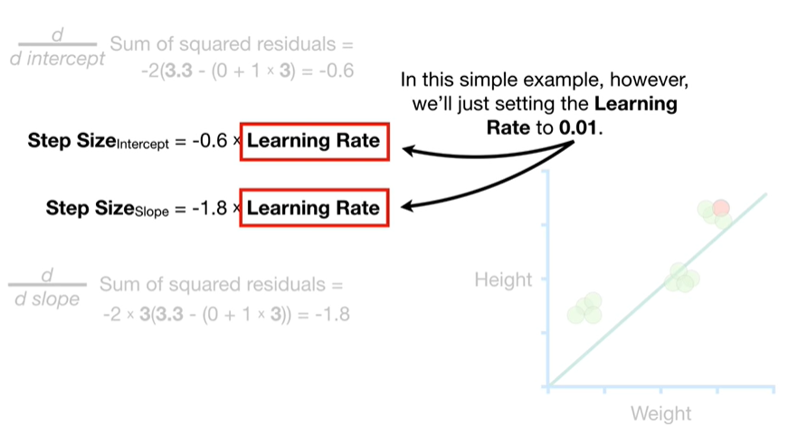

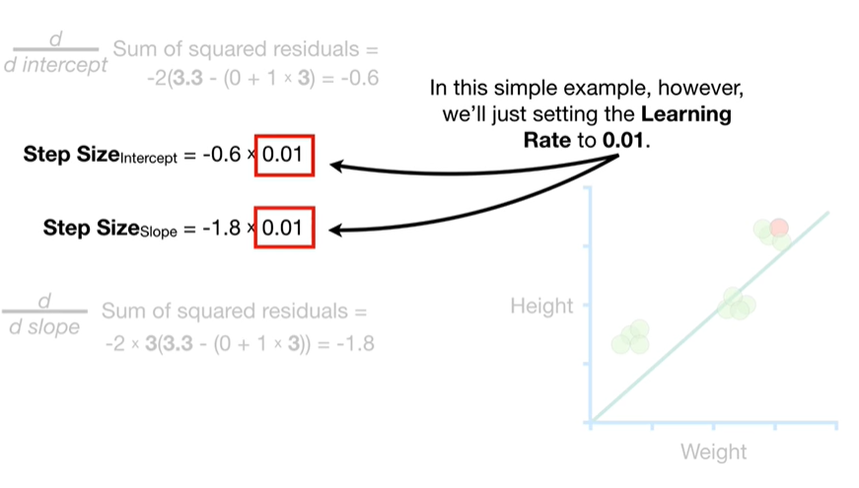

In this simple example, however, we're just setting the learning rate to 0.01.

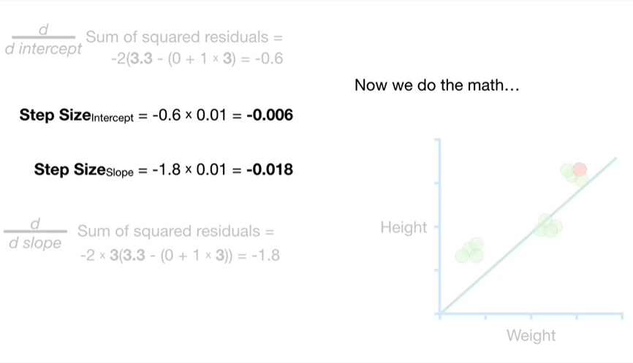

Now we do the math

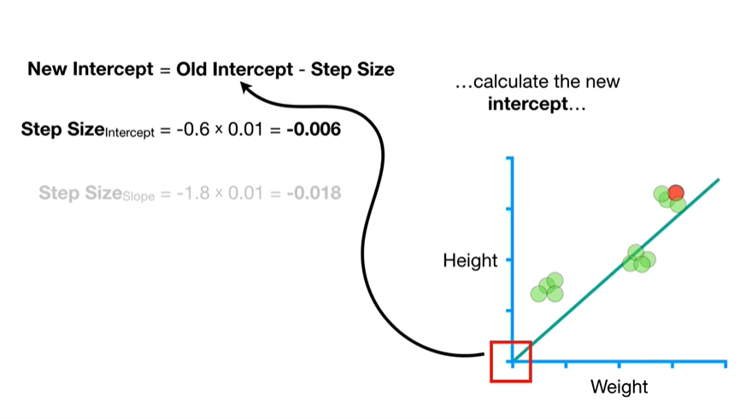

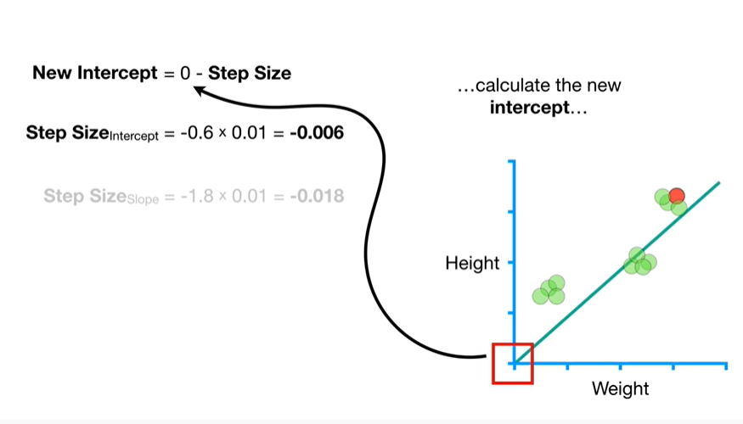

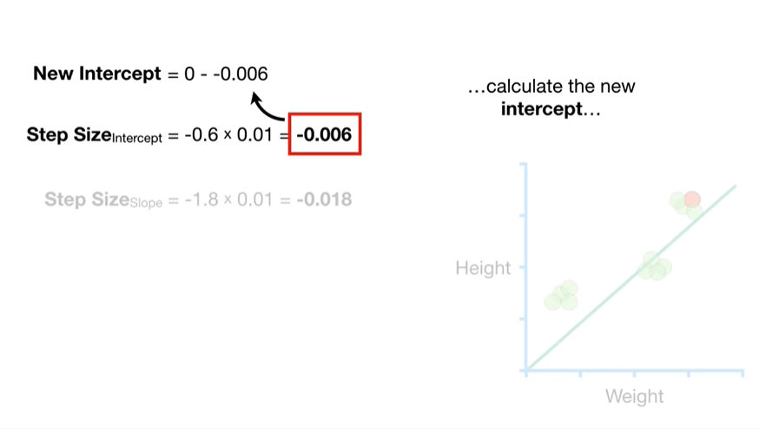

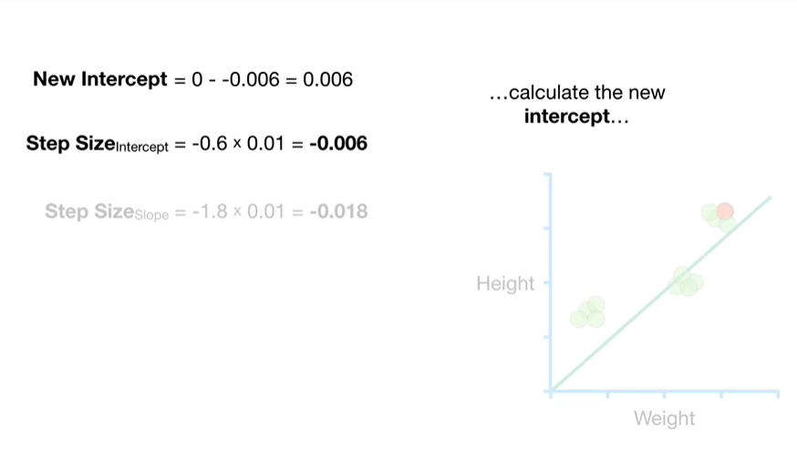

calculate the intercept

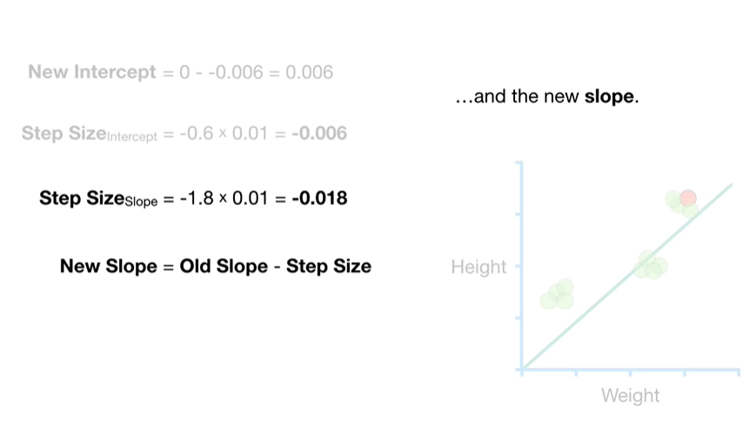

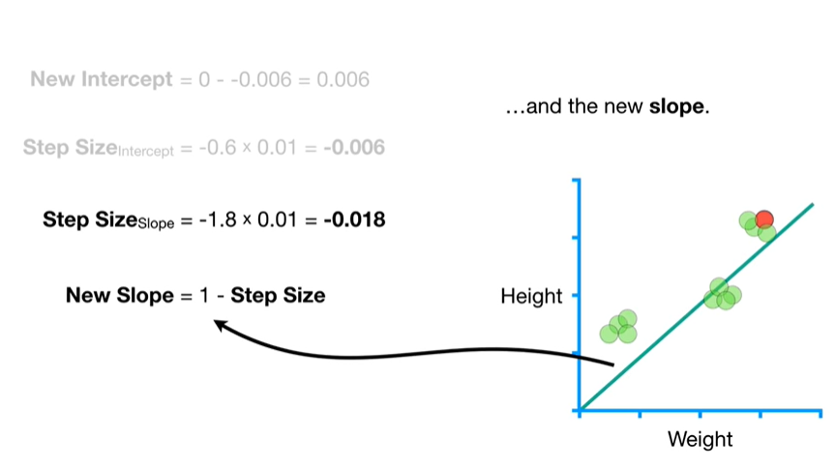

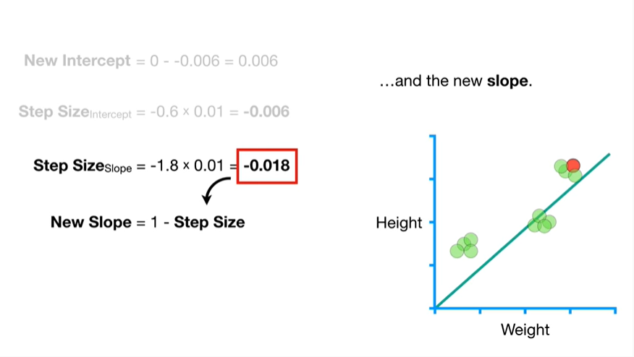

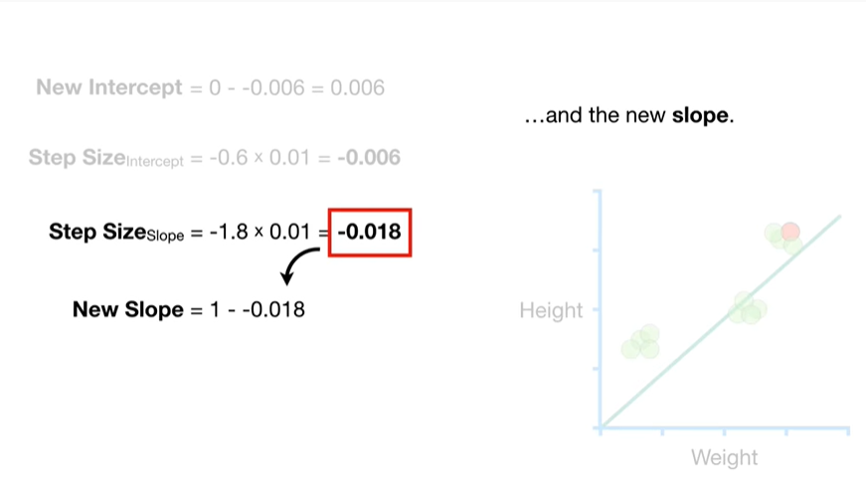

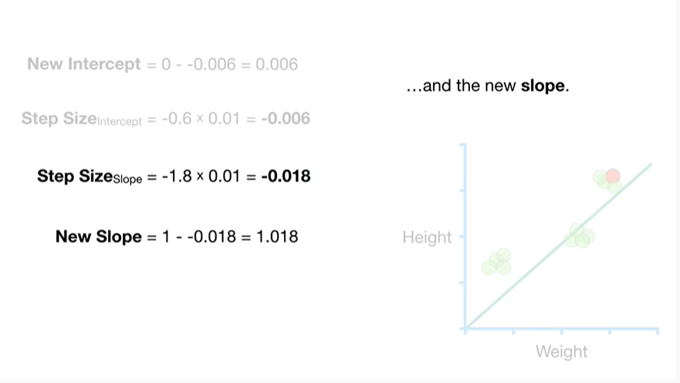

and the new slope.

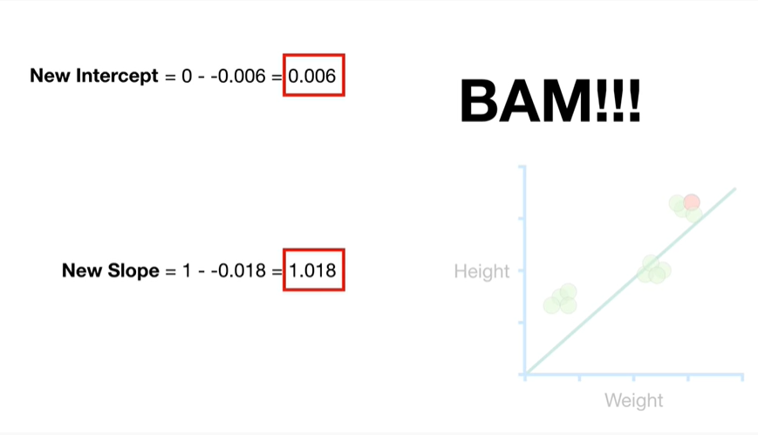

BAM !!!

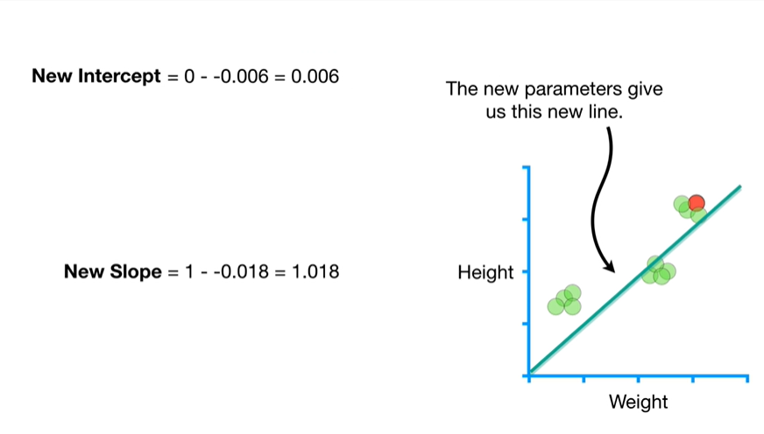

The new parameters give us this new line

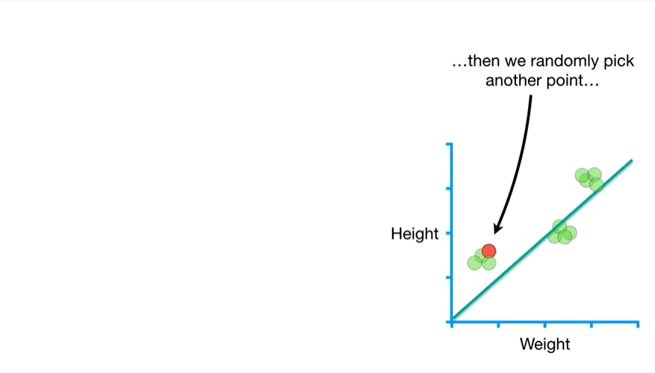

then we randomly pick another point

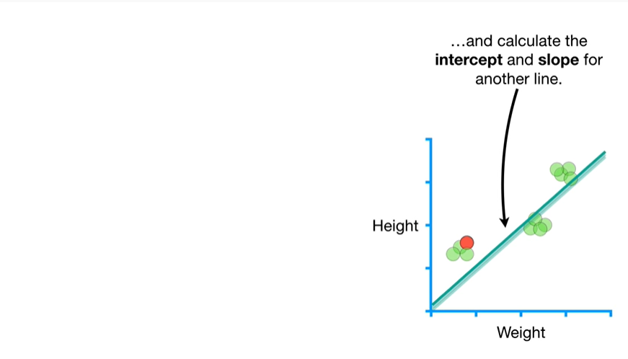

and calculate the intercept and slope for another line.

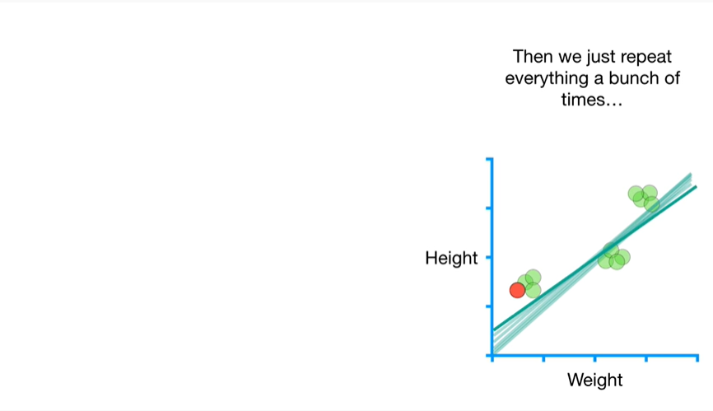

Then we just repeat everything a bunch of times

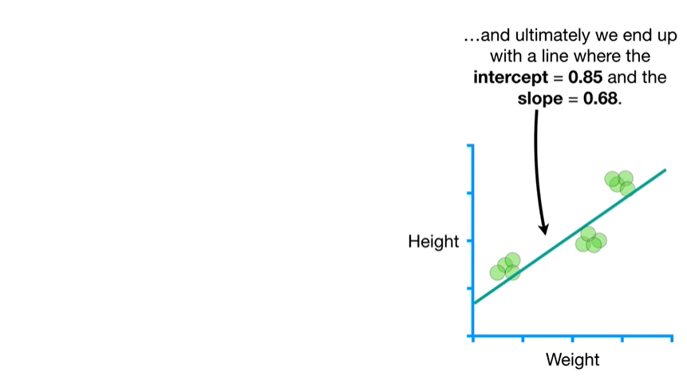

and ultimately we end up with a line where the intercept equals 0.85 and the slope equals zero point six eight.

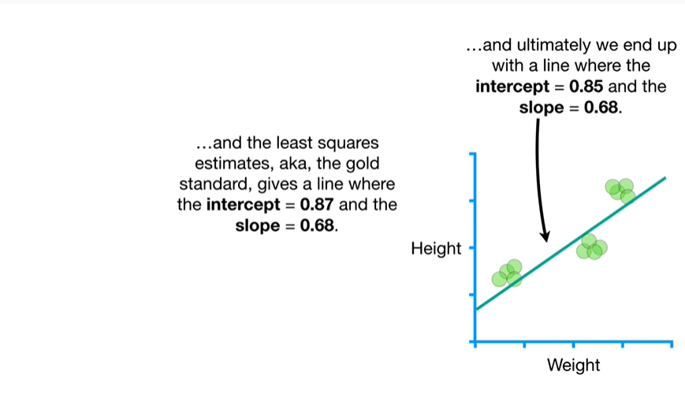

And the least squares estimates aka the gold standard gives a line where the intercept equals 0.87 and the slope equals zero point six eigh.

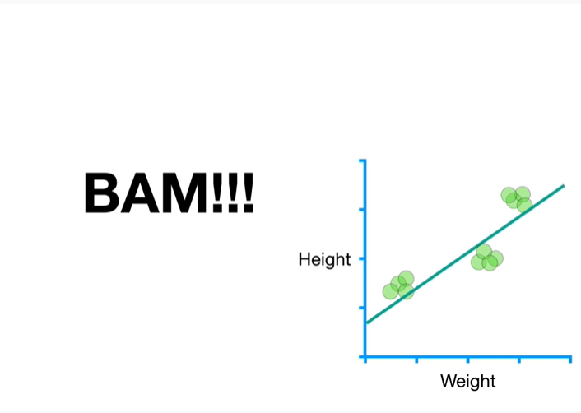

BAM !!!

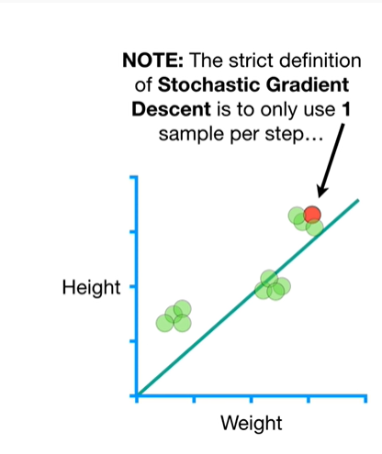

Note : the strict definition of stochastic gradient descent is to only use one sample per step

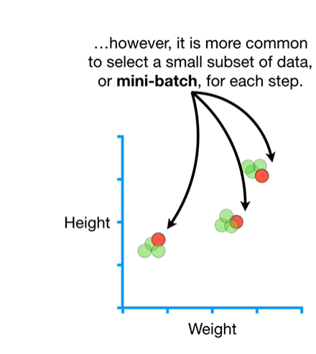

However, it is much more common to select a small subset of data, or mini-batch, for each step.

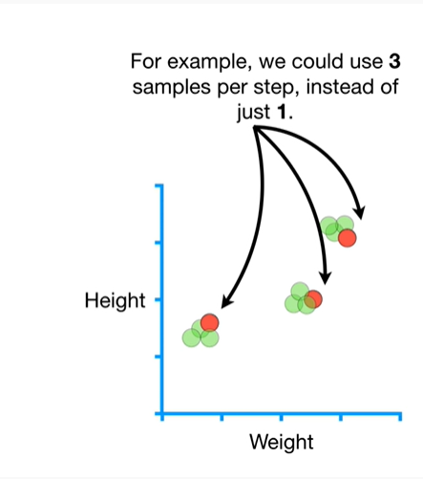

For example we could use three samples per step, instead of just one.

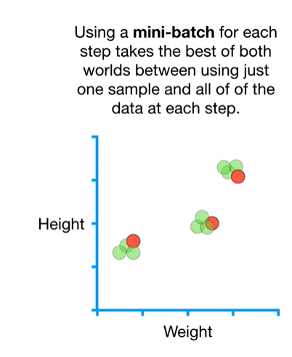

Using a mini batch for each step takes the best of both worlds between using just one sample and all of the data at each step.

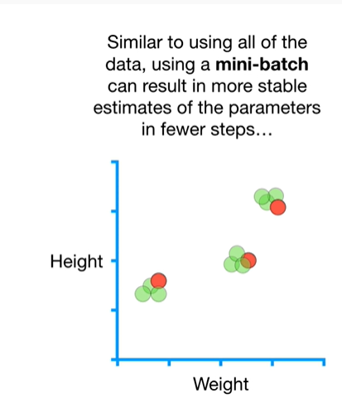

Similar to using all of the data using a mini batch can result in more stable estimates for the parameters in fewer steps

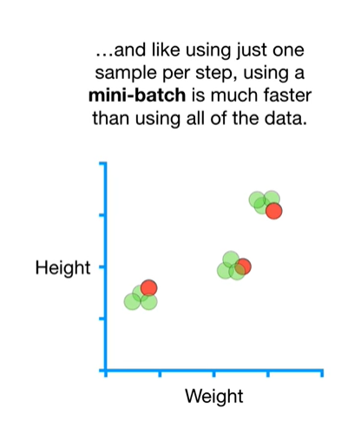

and like using just one sample per step, using a mini batch is much faster than using all of the data.

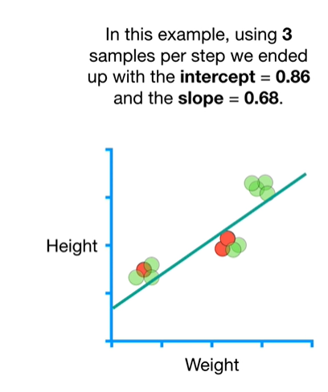

In this example, using three samples per step we ended up with an intercept equals zero point eight six and the slope equals zero point six eight.

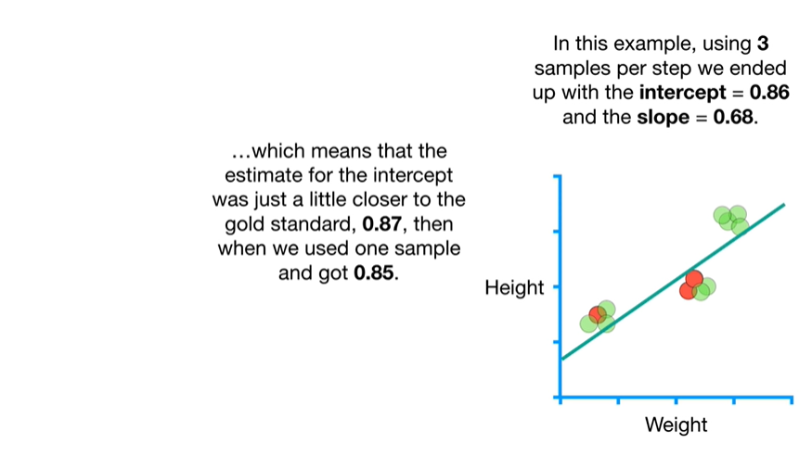

Which means that the estimate for the intercept was just a little closer to the gold standard, 0.87, then when we used one sample and got zero point eight five.

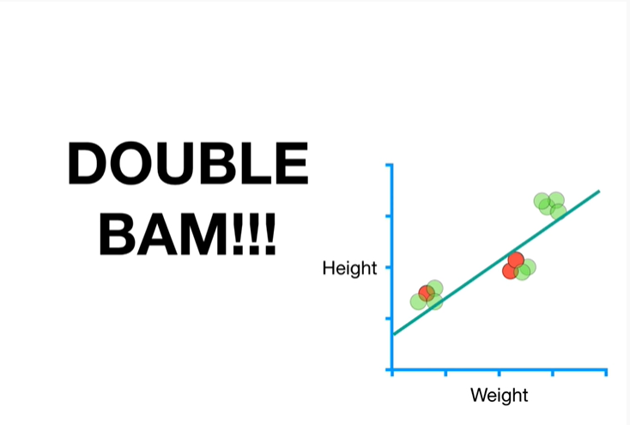

Double bam !!!

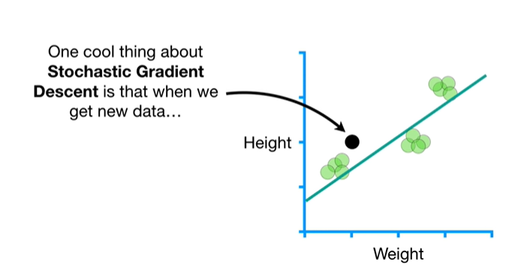

One cool thing about stochastic gradient descent is that when we get new data

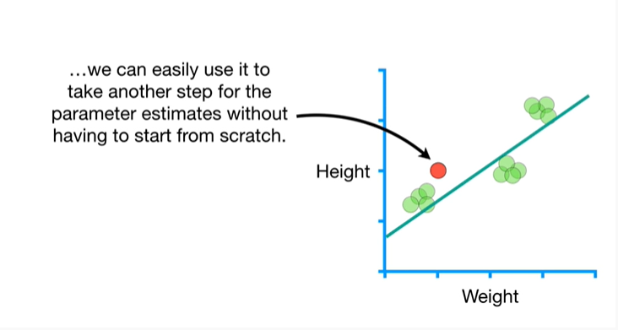

we can easily use it to take another step for the parameter estimates without having to start from scratch.

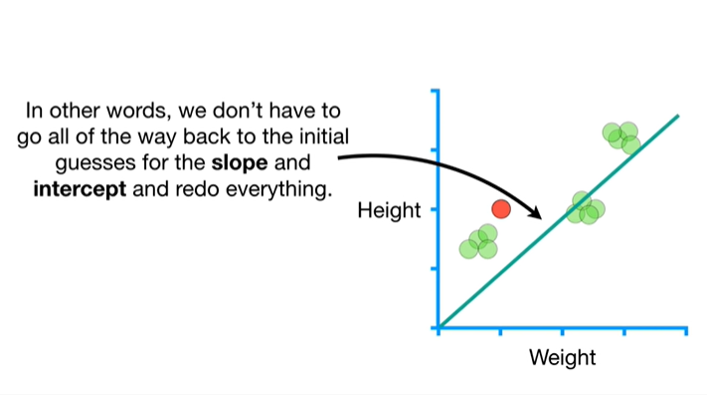

In other words we don't have to go all the way back to the initial guesses for the slope and intercept and redo everything.

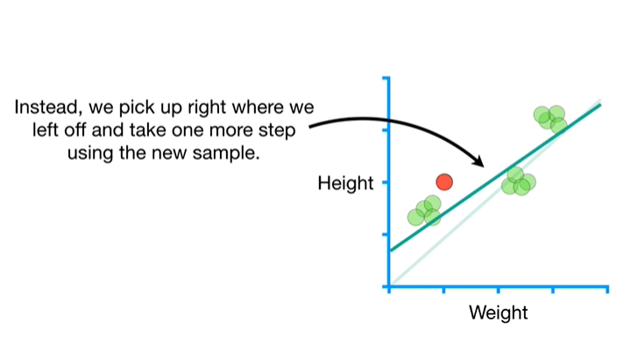

Instead we pick up right where we left off and take one more step using the new sample.

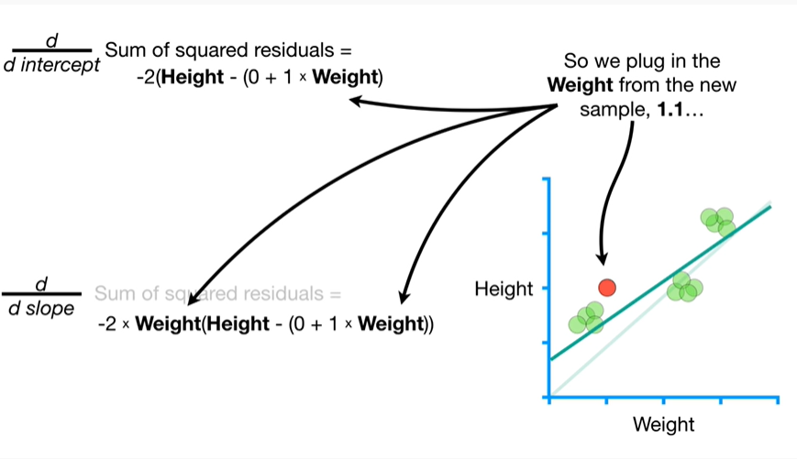

So we plug in the weight from the new sample 1.1

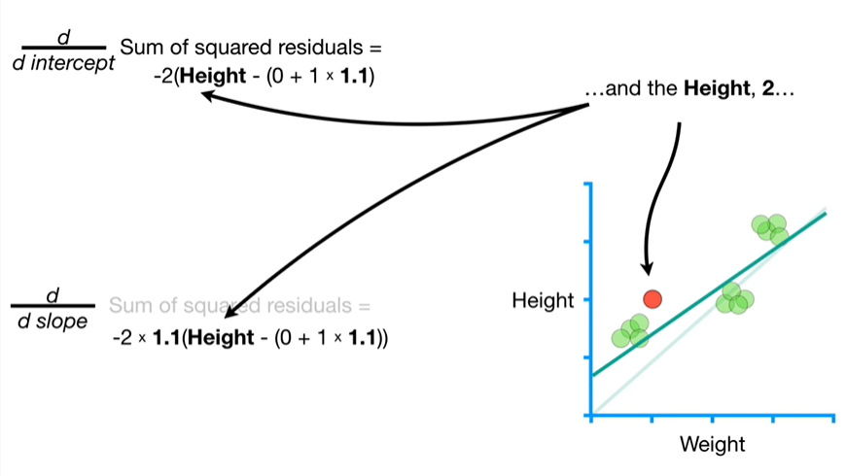

and the height 2

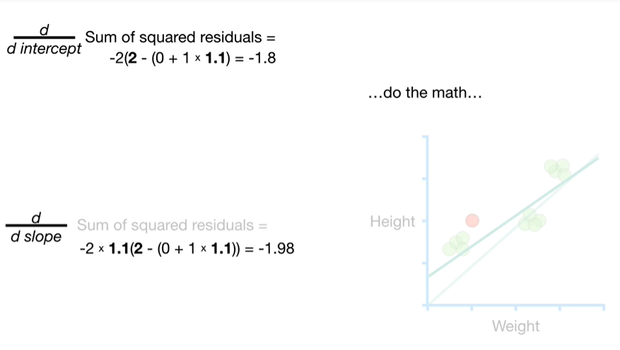

do the math

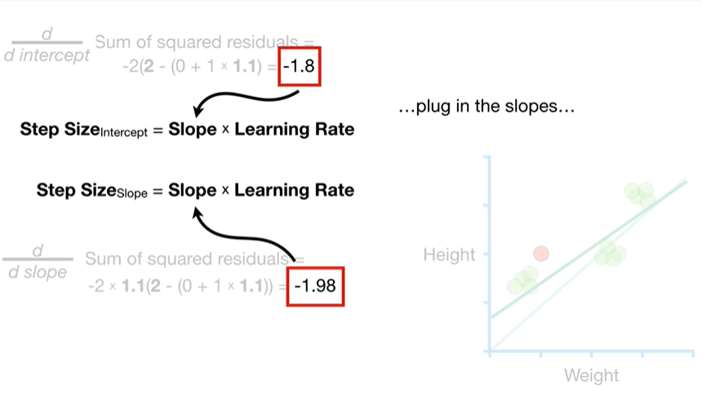

plug in the slopes

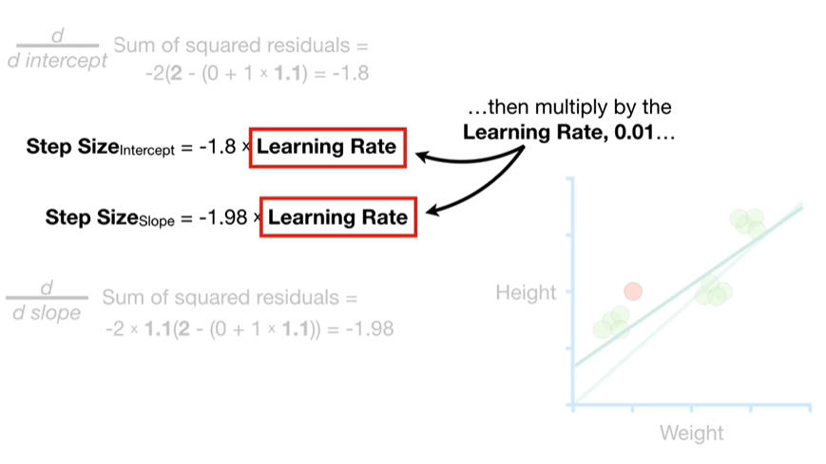

then multiply by the learning rate 0.01

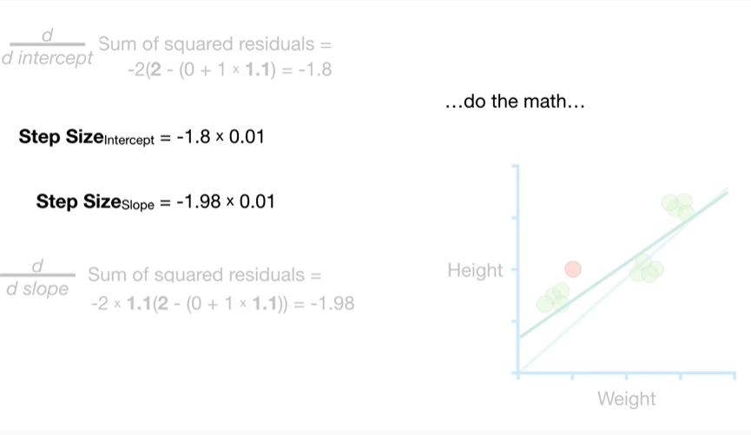

do the math

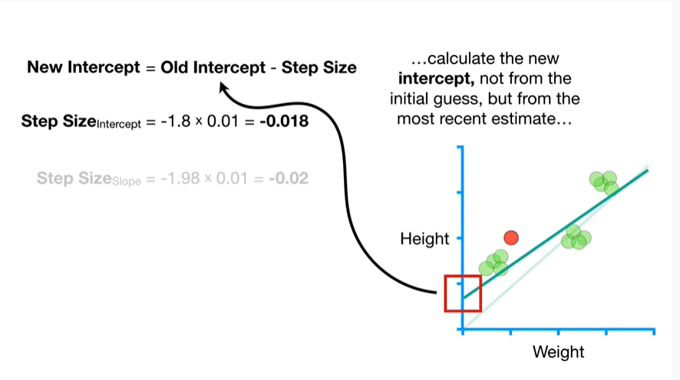

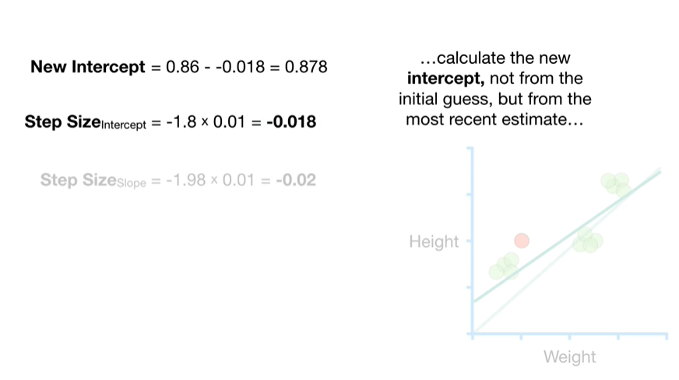

caclulate the nex intercept, not from the initial guess, but from the most recent estimate

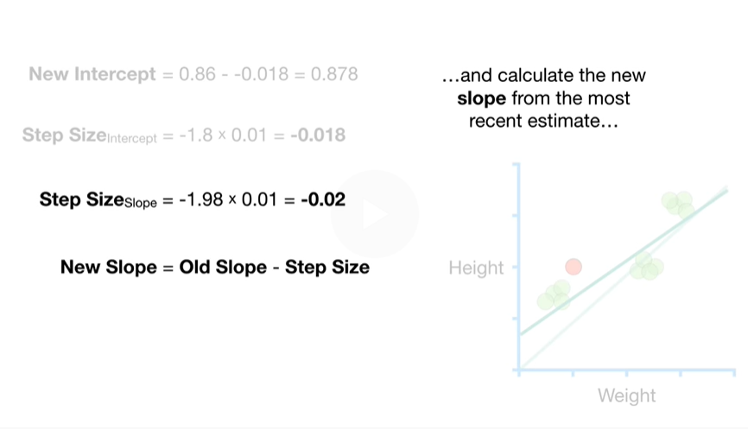

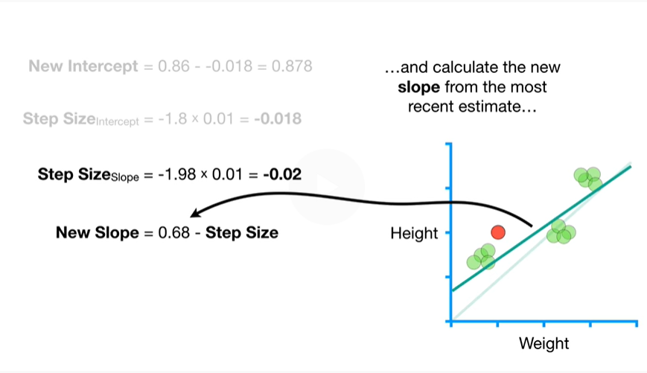

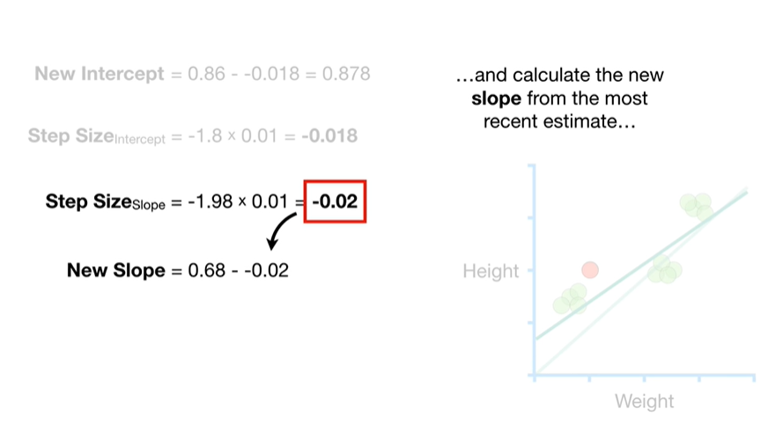

and calculate the new slope from the most recent estimate

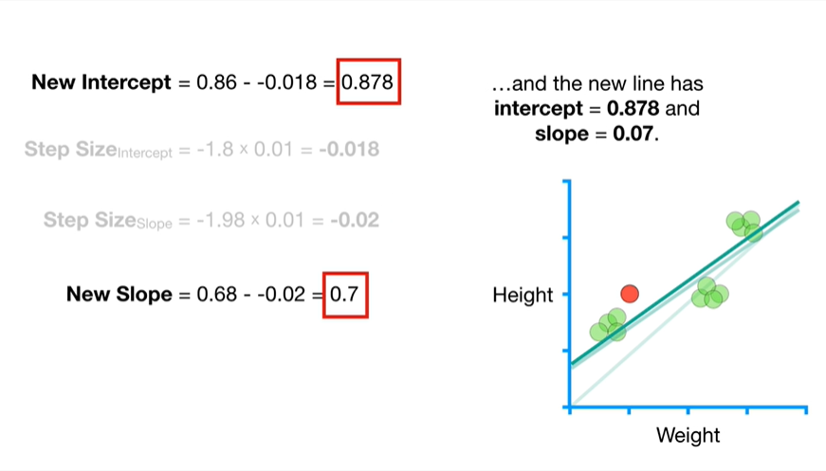

and the new line has intercept equals zero point eight seven eight and slope equals zero point seven.

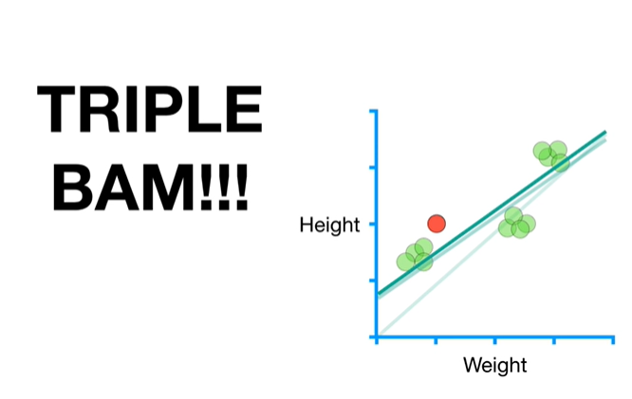

Triple bam !!!

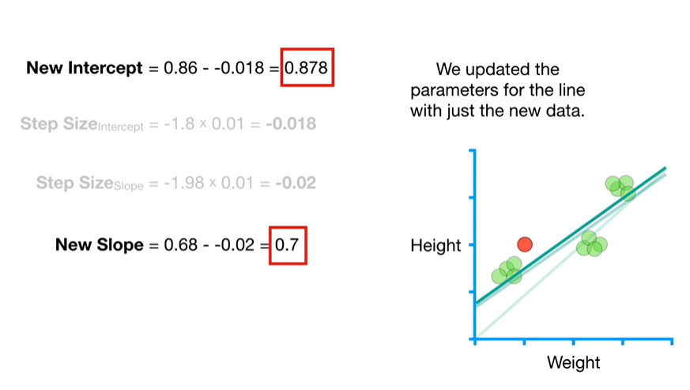

We updated the parameters for the line with just the new data.



In summary :

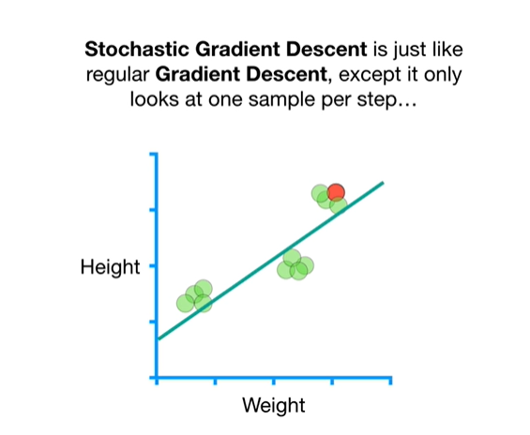

stochastic gradient descent is just like regular gradient descent, except it only looks at one sample per step

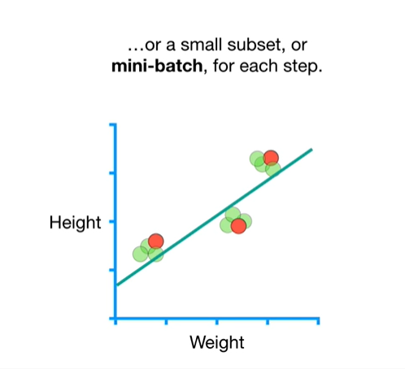

or a small subset, or mini batch, for each step.

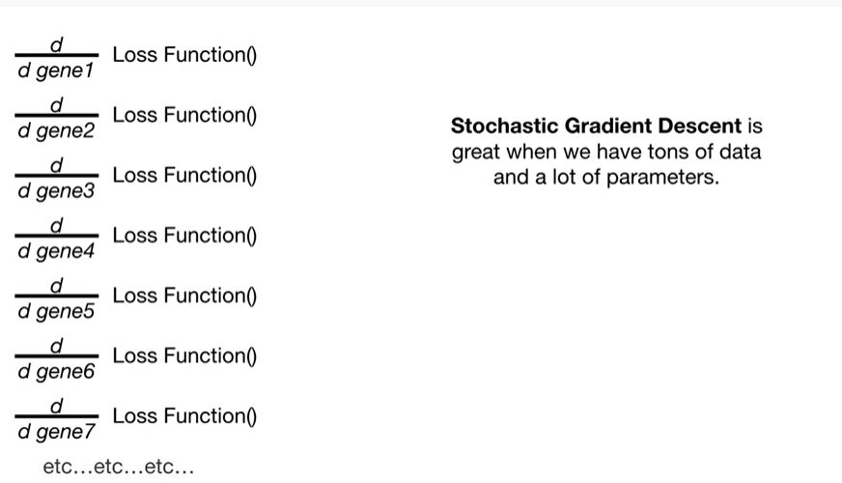

Stochastic gradient descent is great when we have tons of data and lots of parameters.

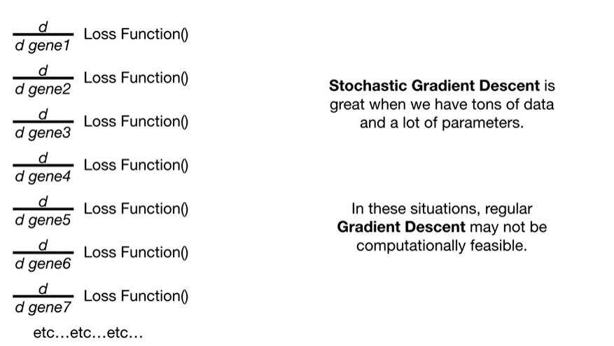

In these situations regular gradient descent may not be computationally feasible.

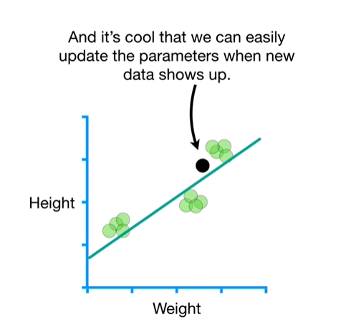

And it's cool that we can easily update the parameters when new data shows up.